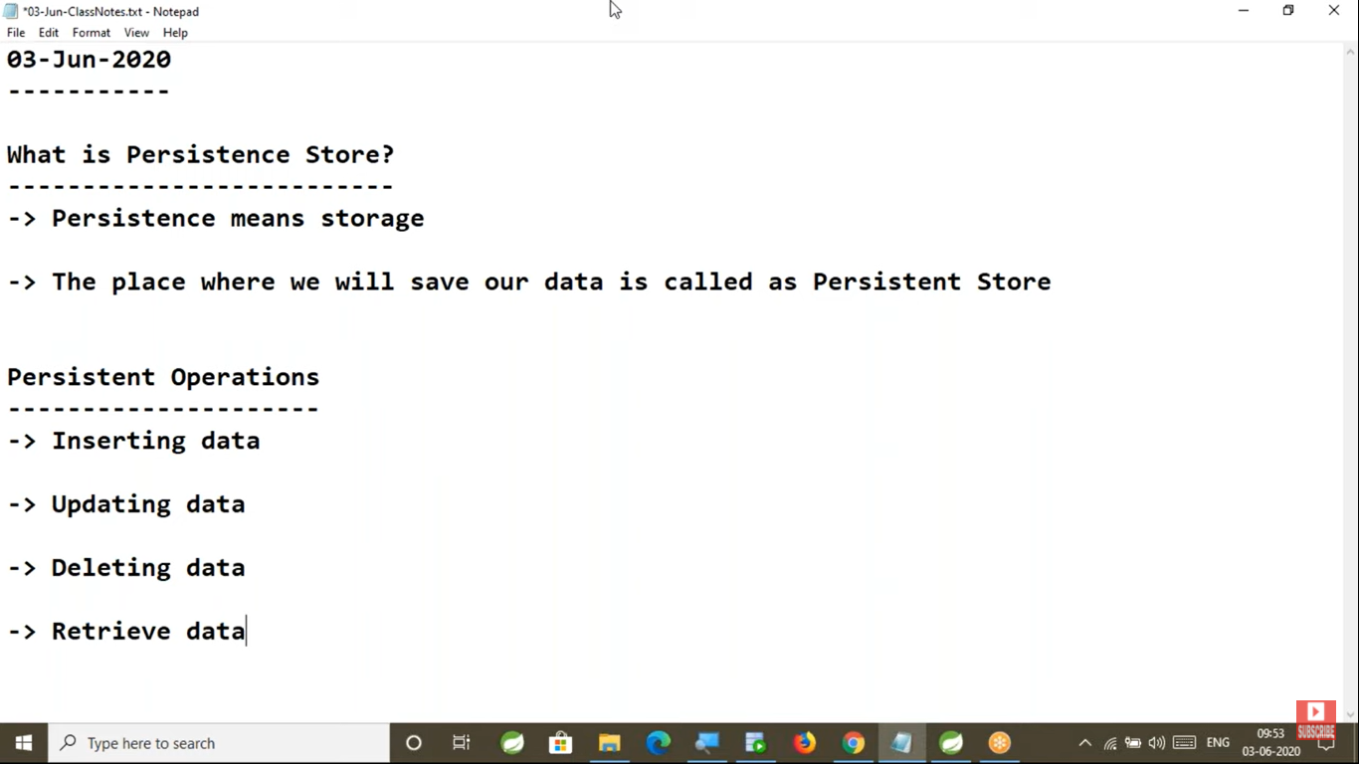

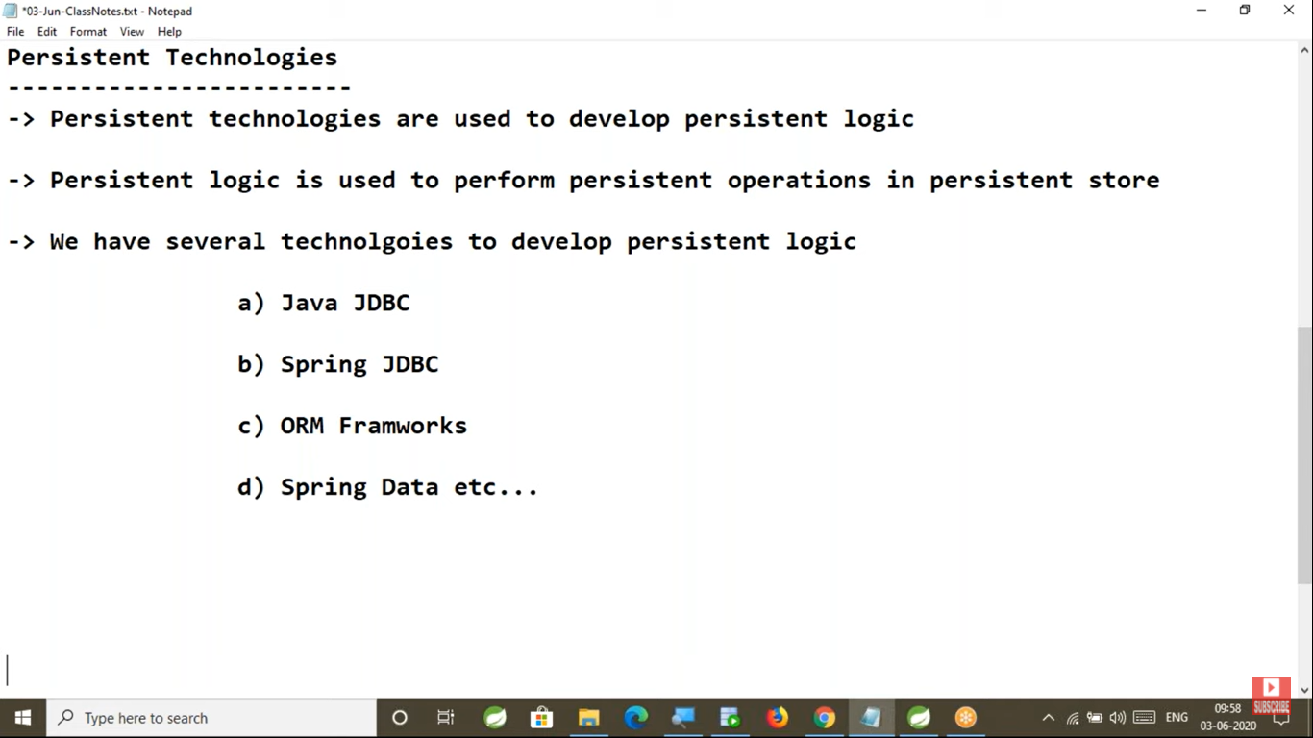

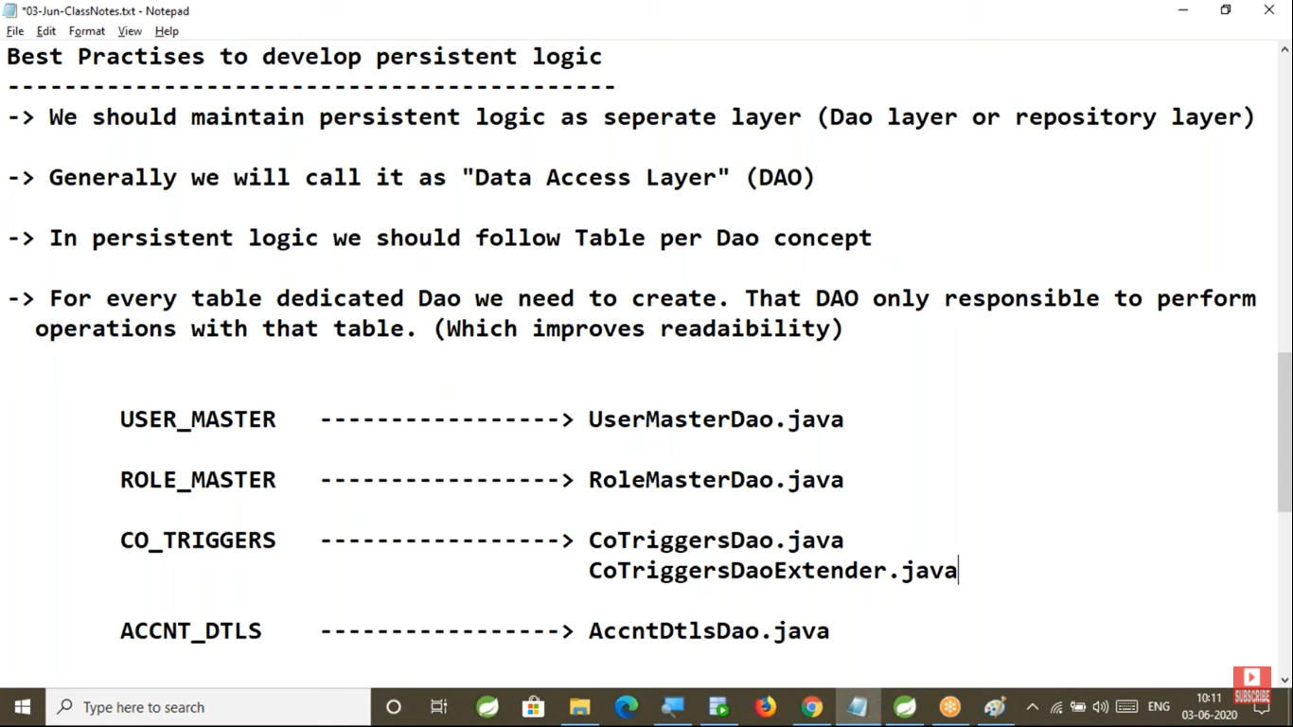

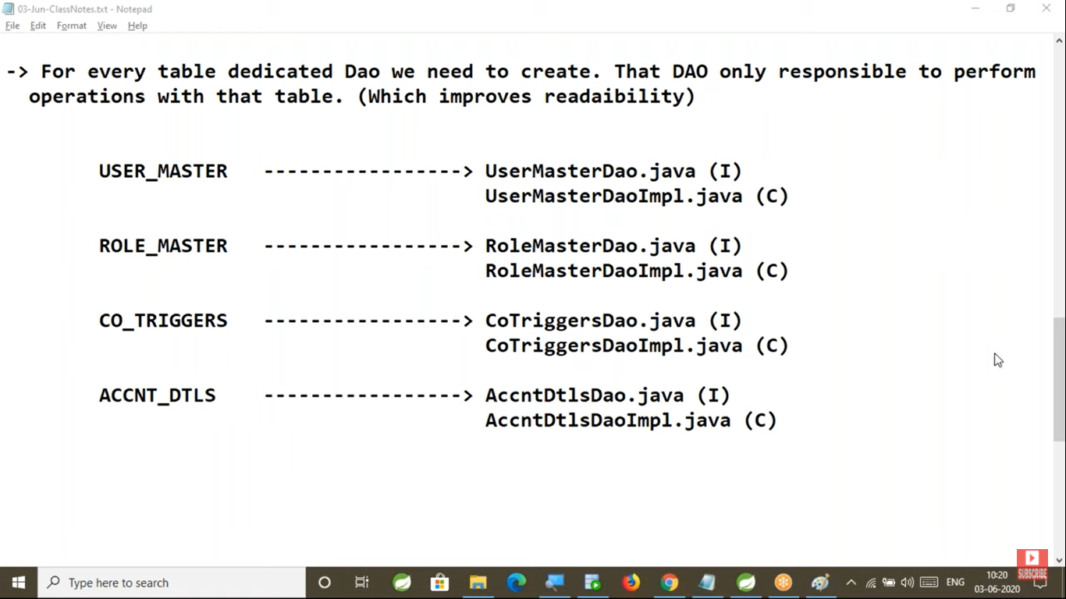

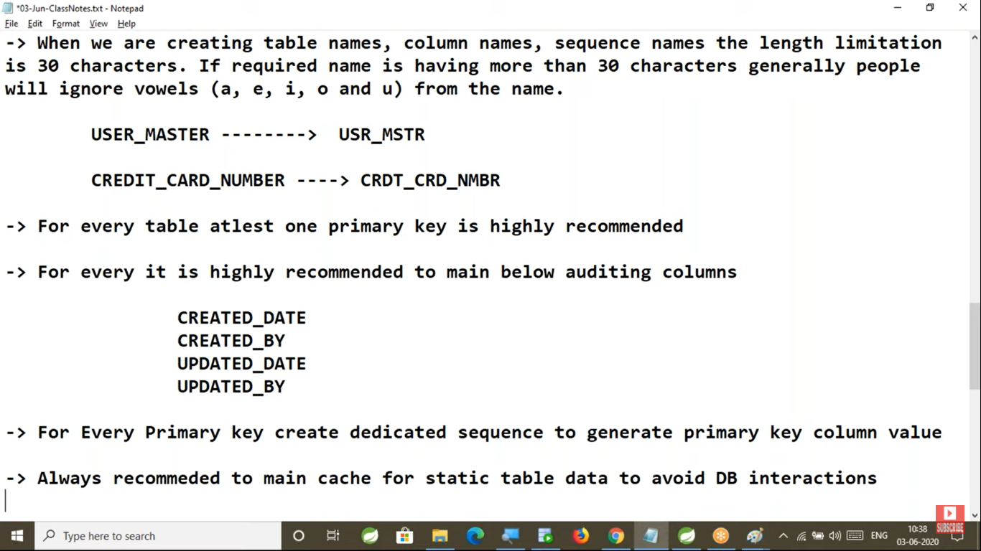

Always recommended to maintain cache for static table data to avoid DB interactions.

---------------------------------------------------------------------------

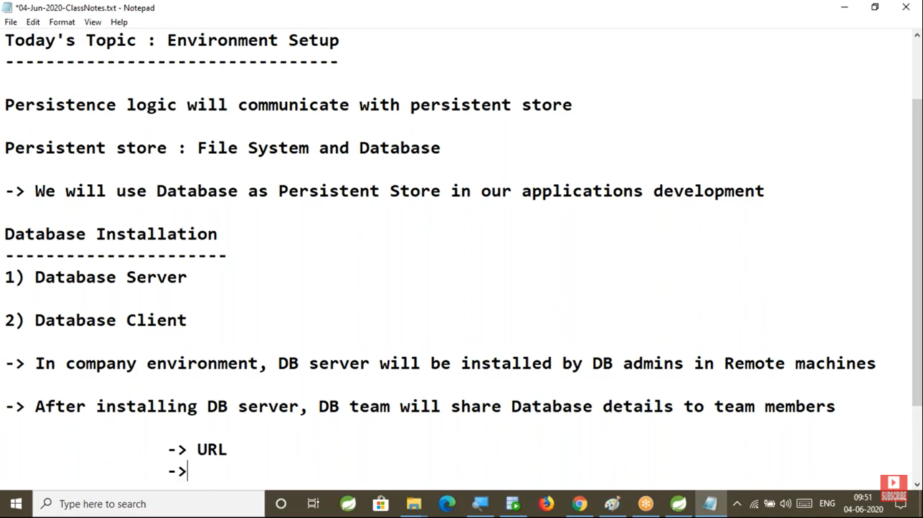

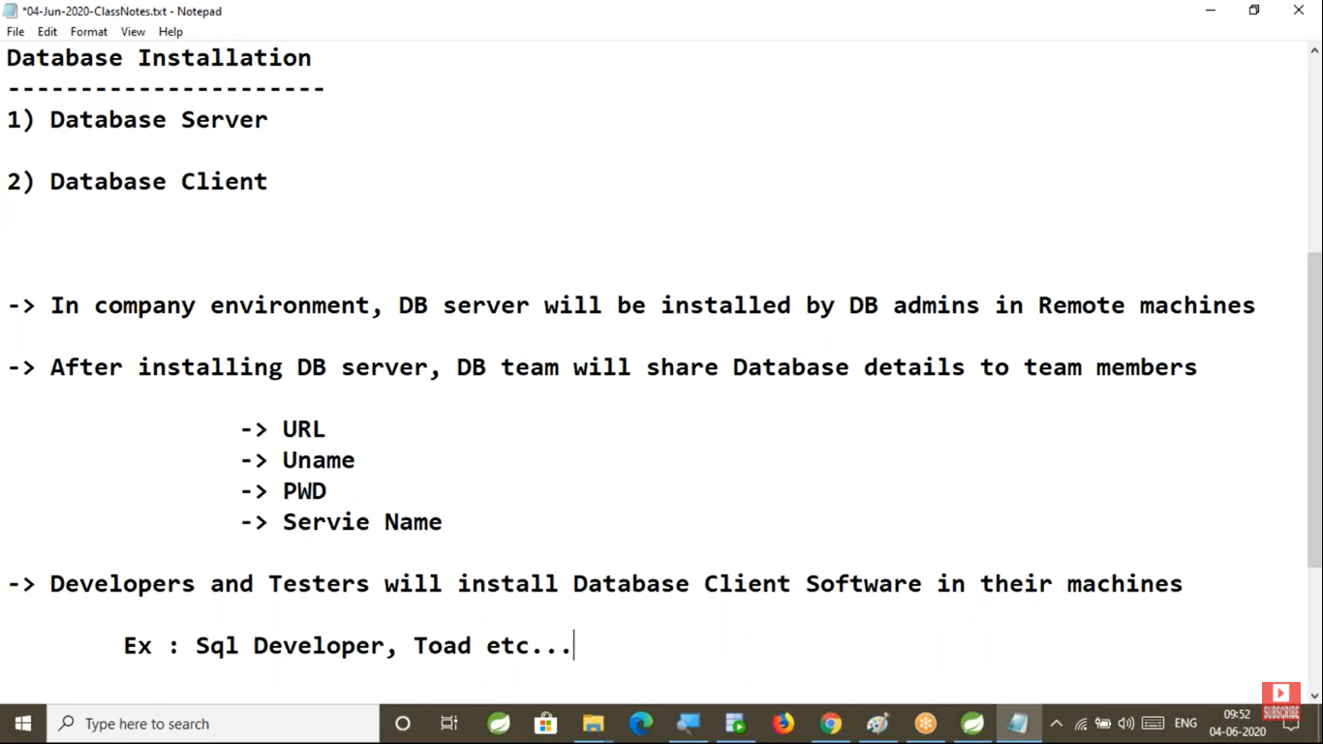

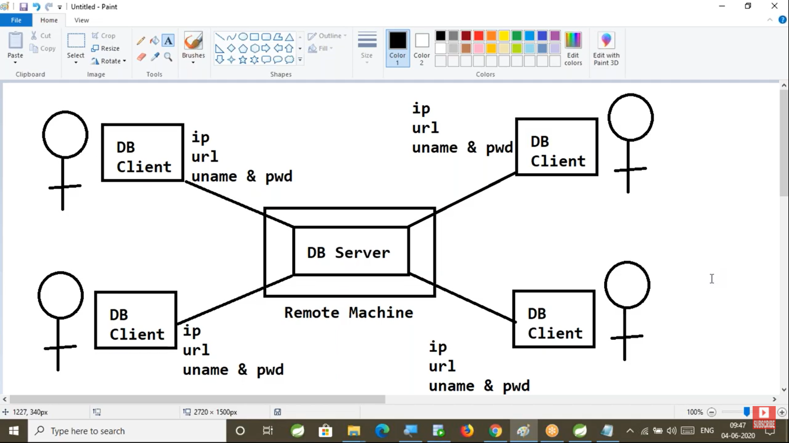

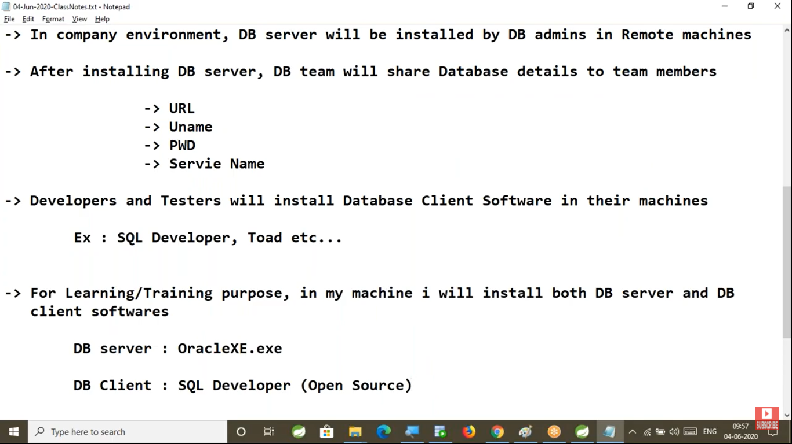

We connect to the database using SQL command Line also

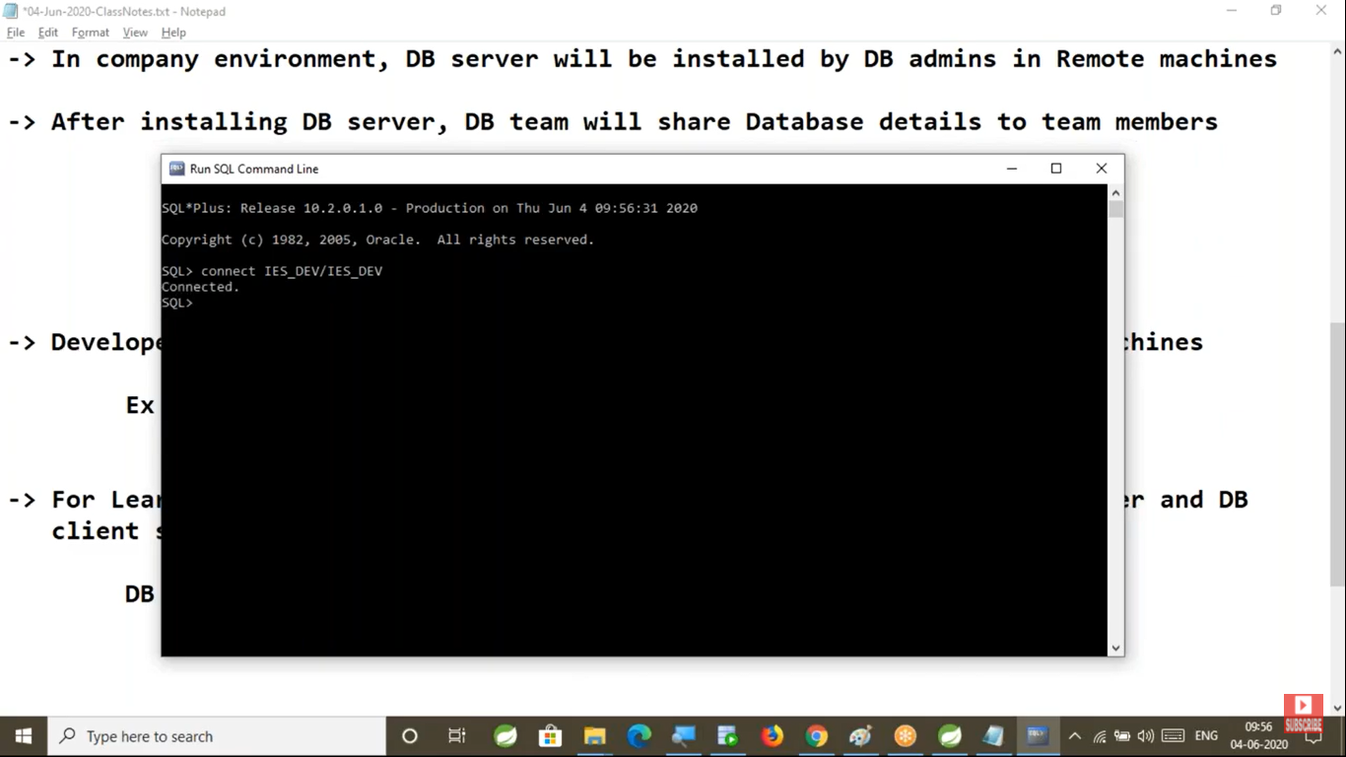

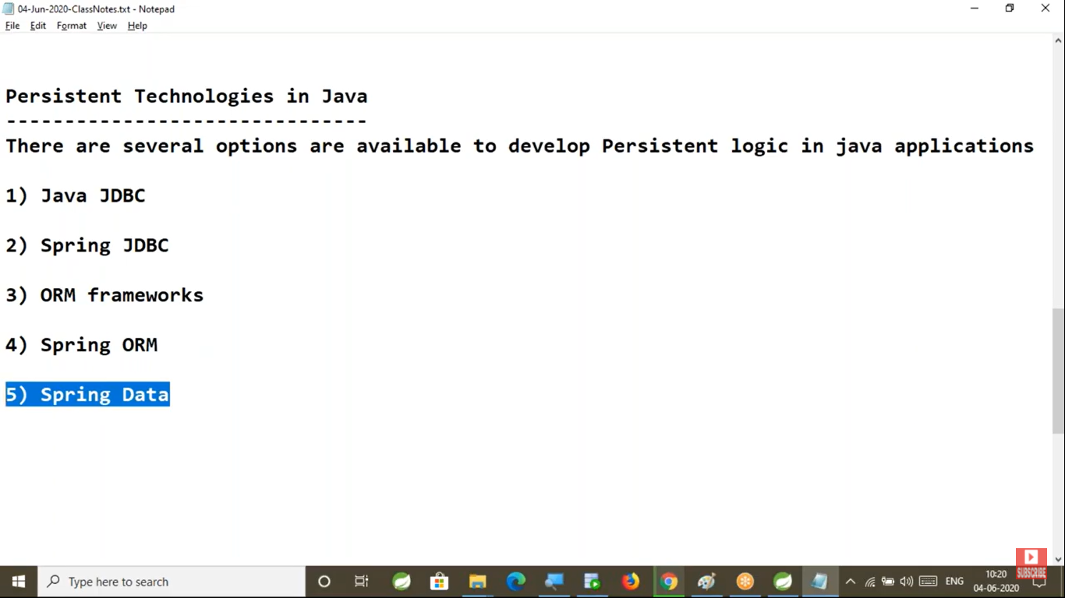

The below operations are very Generic operations on database tables

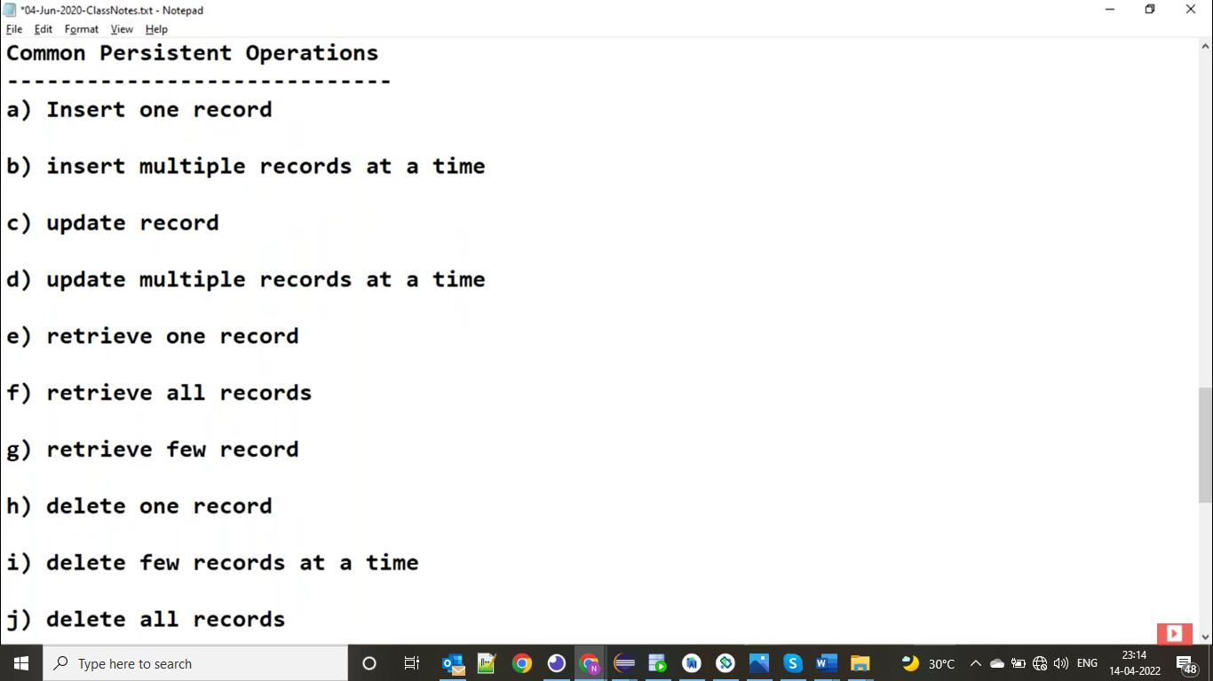

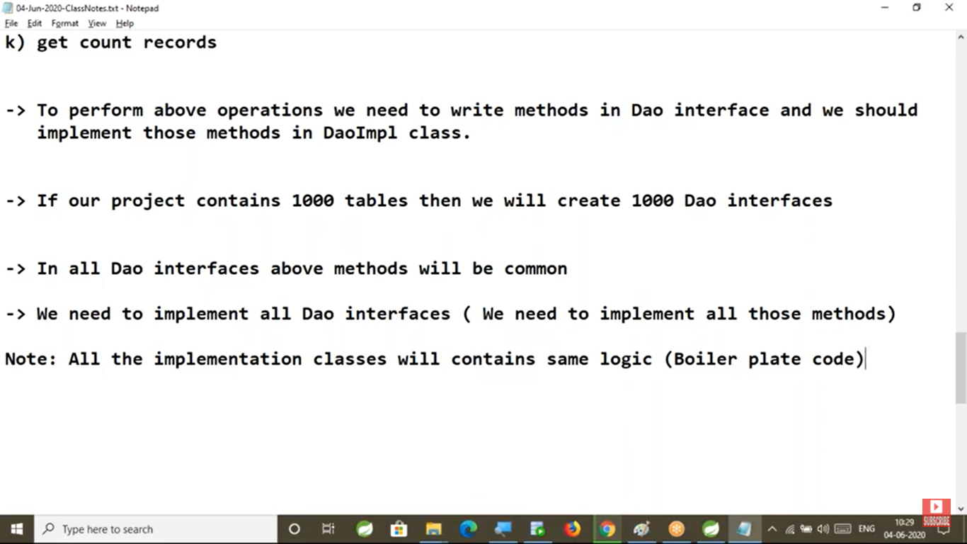

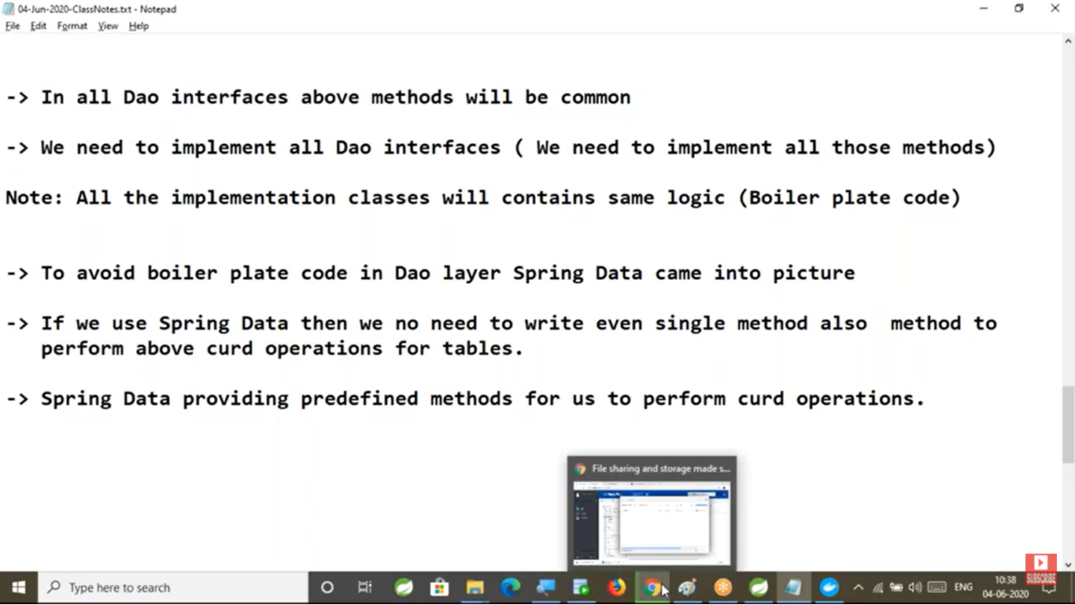

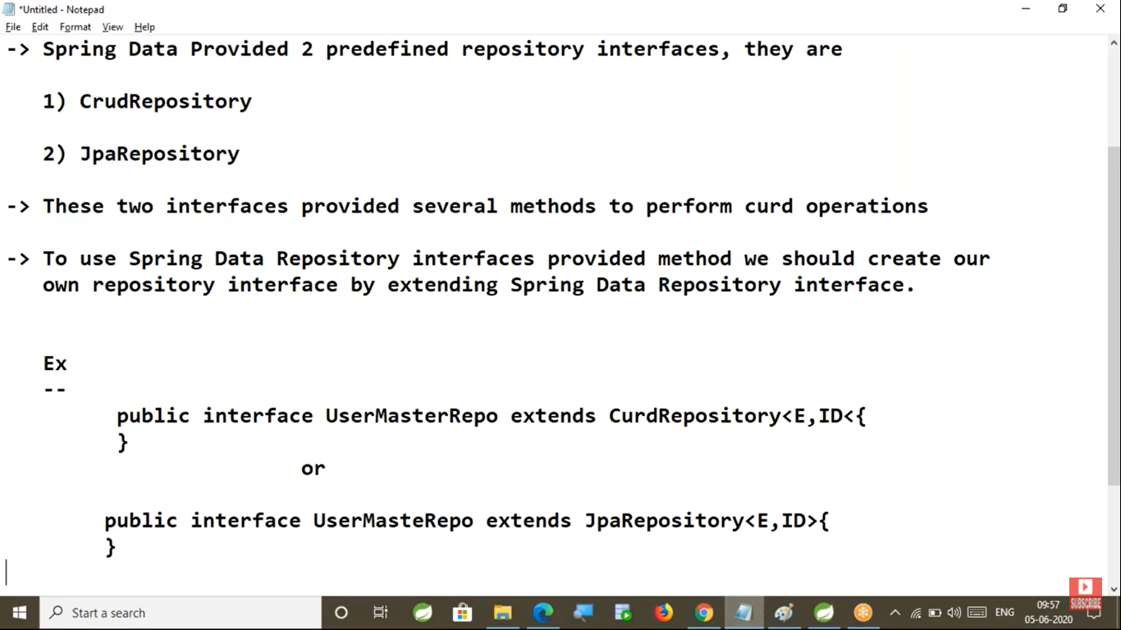

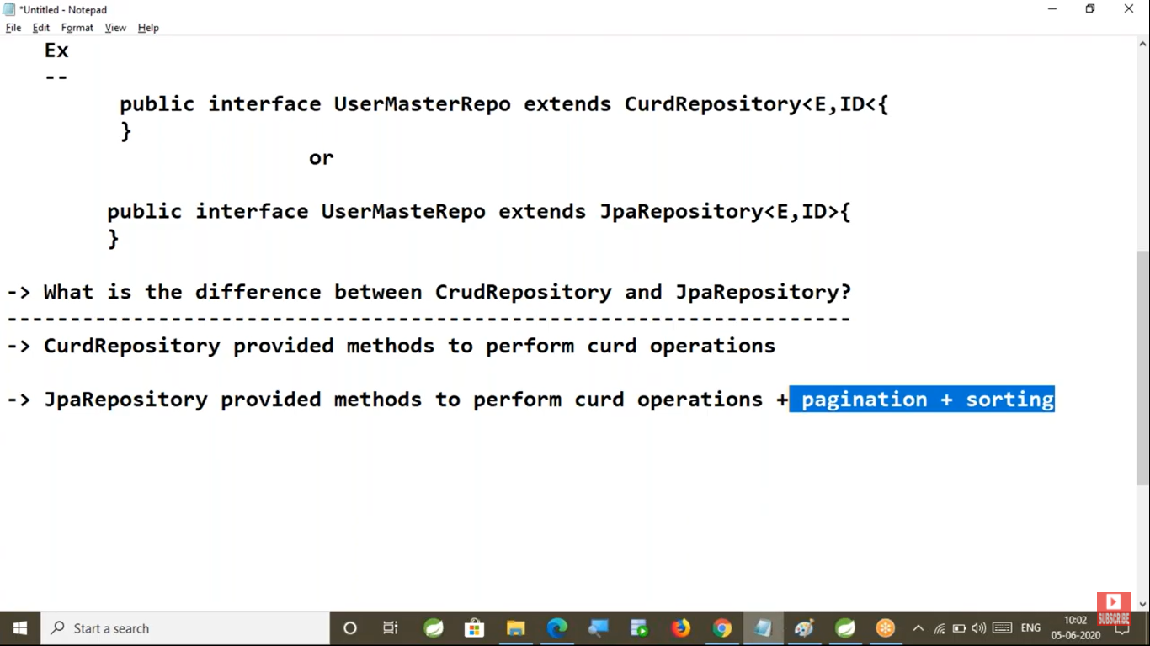

Pagination: The process of displaying records in multiple pages is called pagination

Note: We can say JpaRepository is superior to CrudRepository

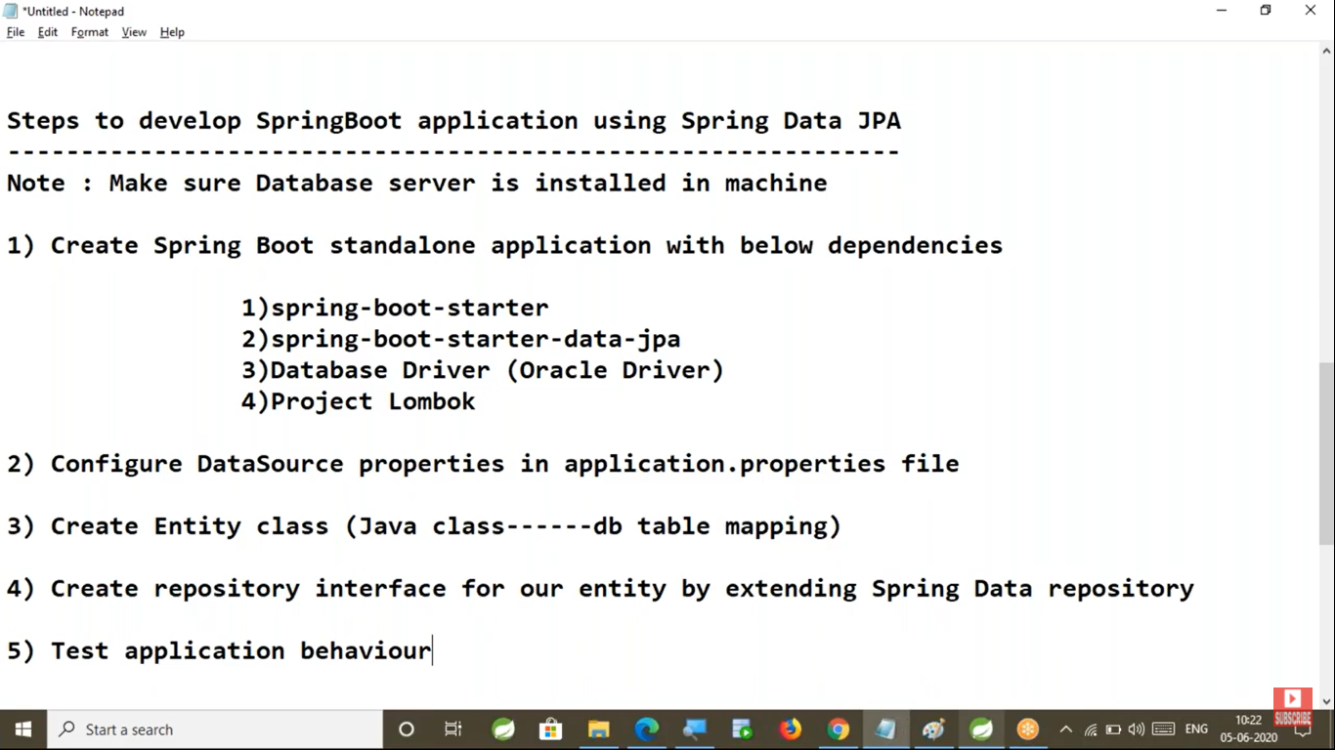

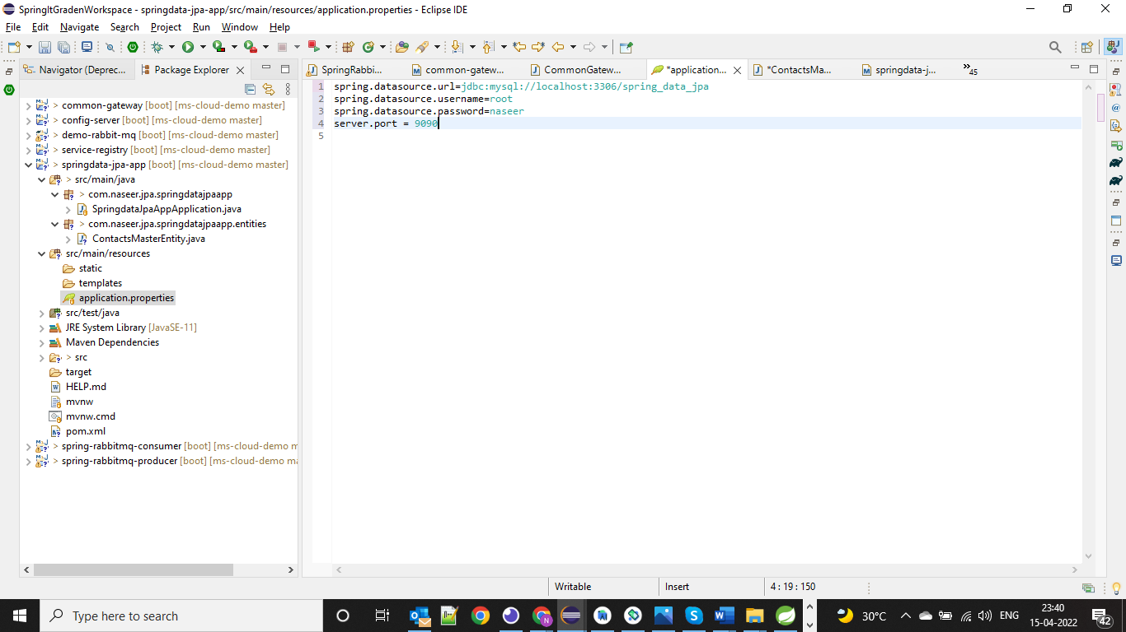

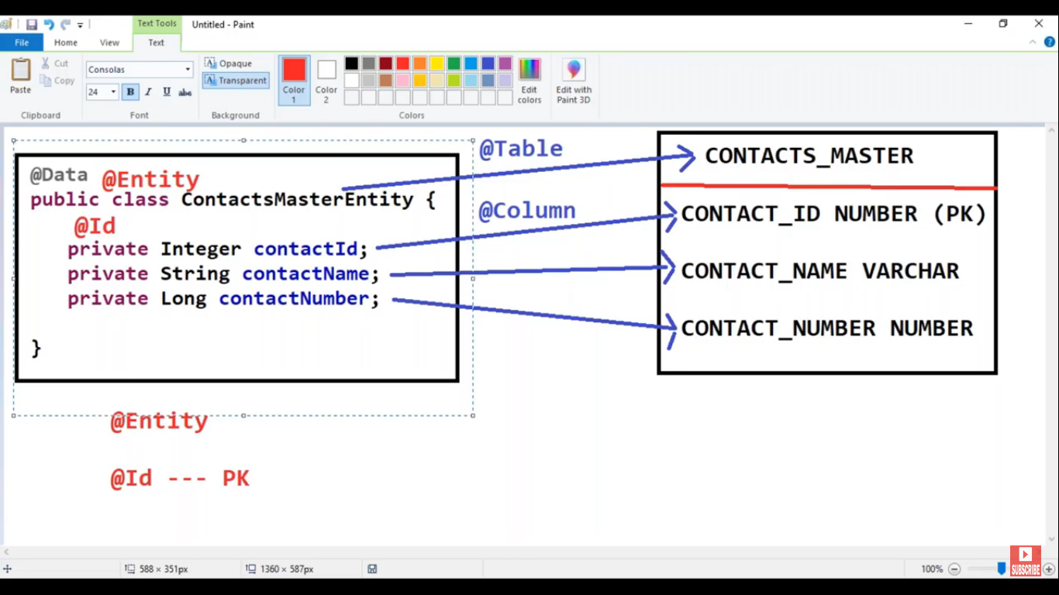

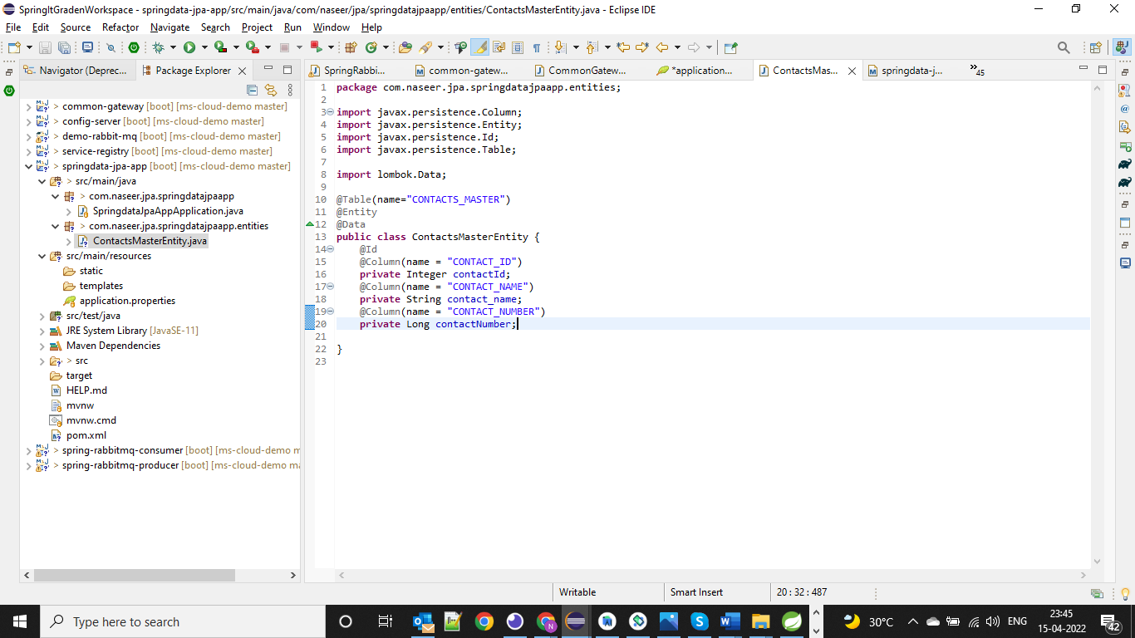

Note: If Table and Entity names are same then we no need to mention the @Table annotation.

If Column name and Entity property names are same then we no need to mention the @Column annotation

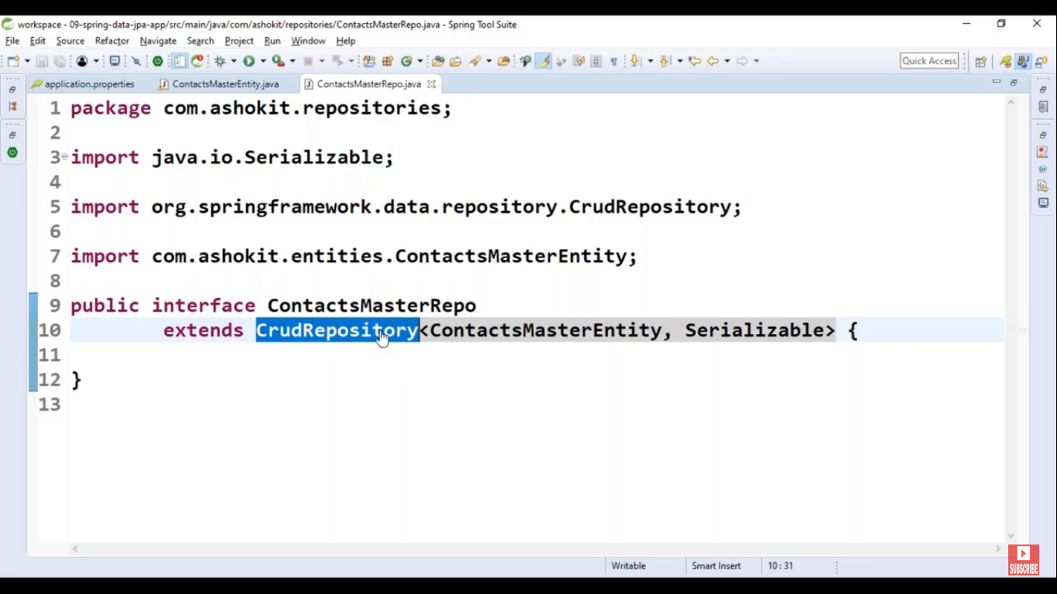

We can mention primary id type as Serializable also

Note: No need to mention the @Repository annotation to the repository class because this interface extended from CrudRepository.

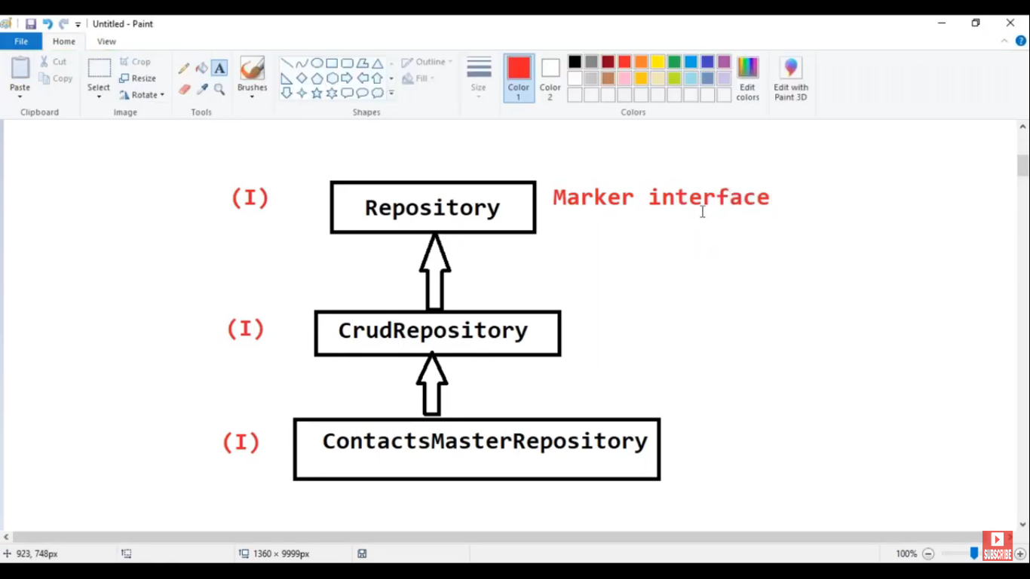

**Note: Spring Data will create the implemented class for our repository interface at runtime using proxy design pattern**

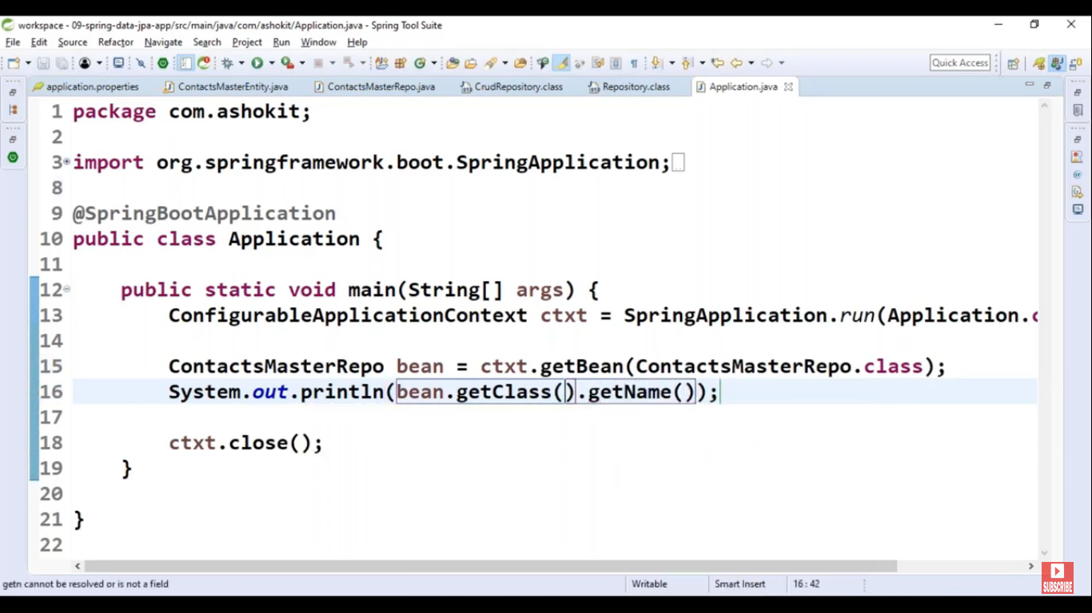

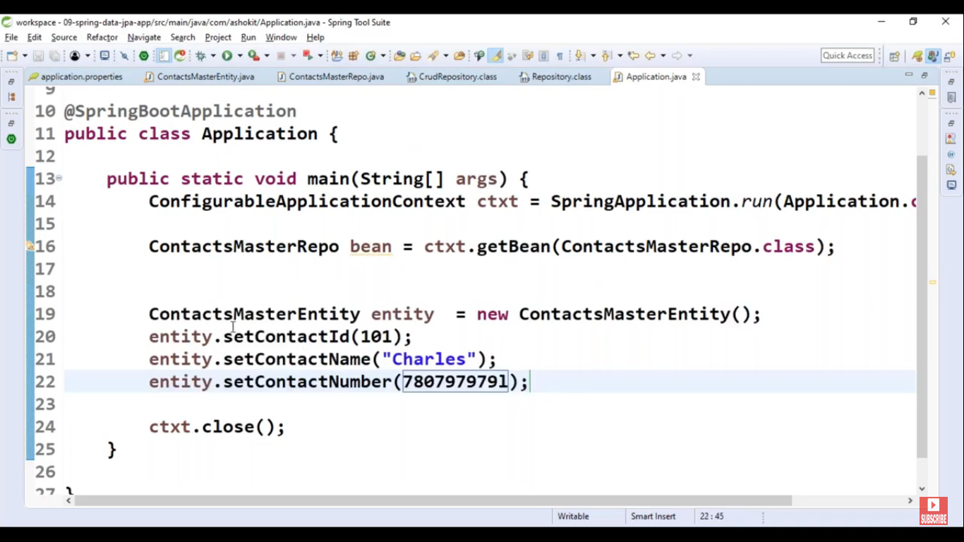

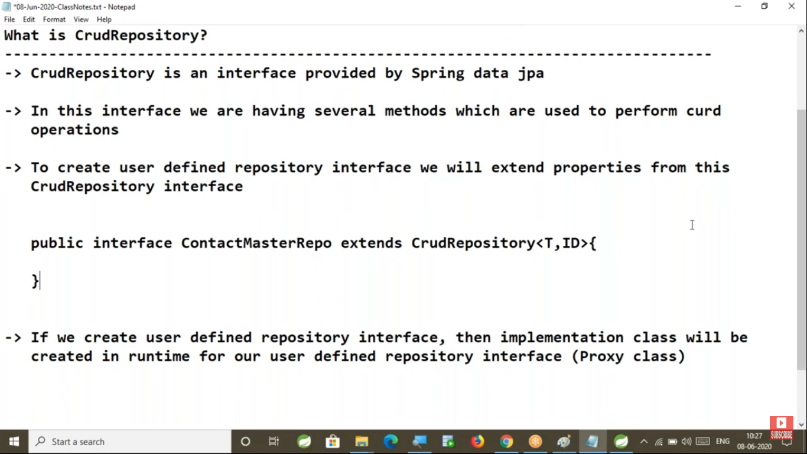

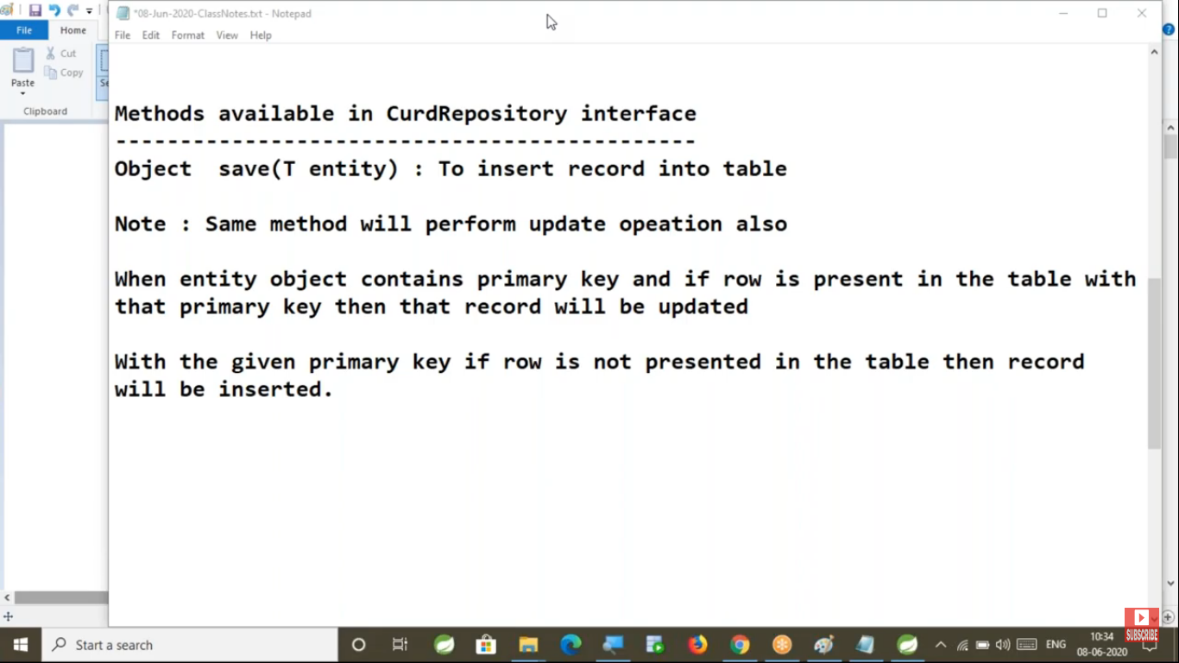

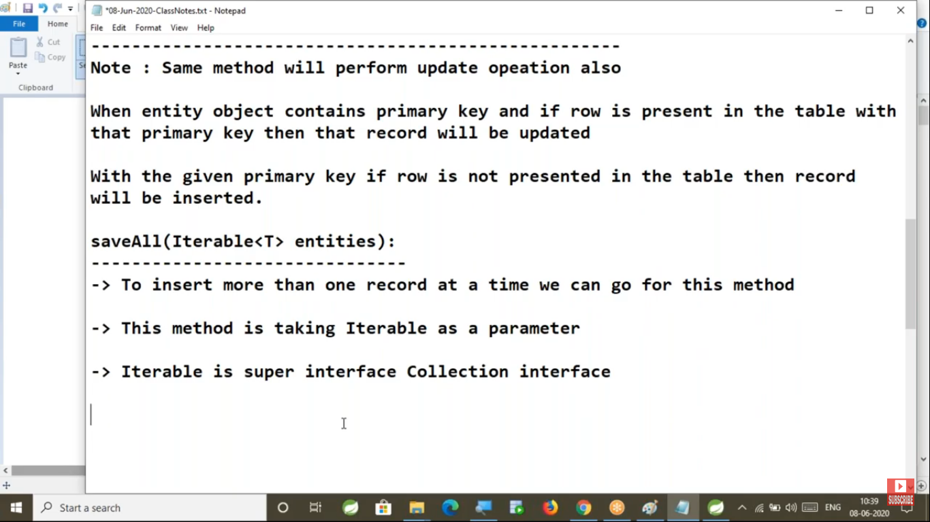

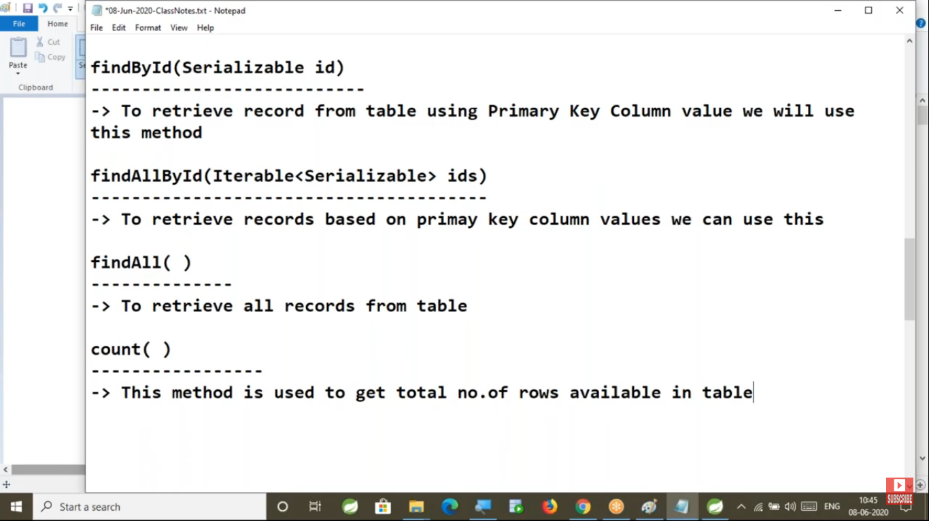

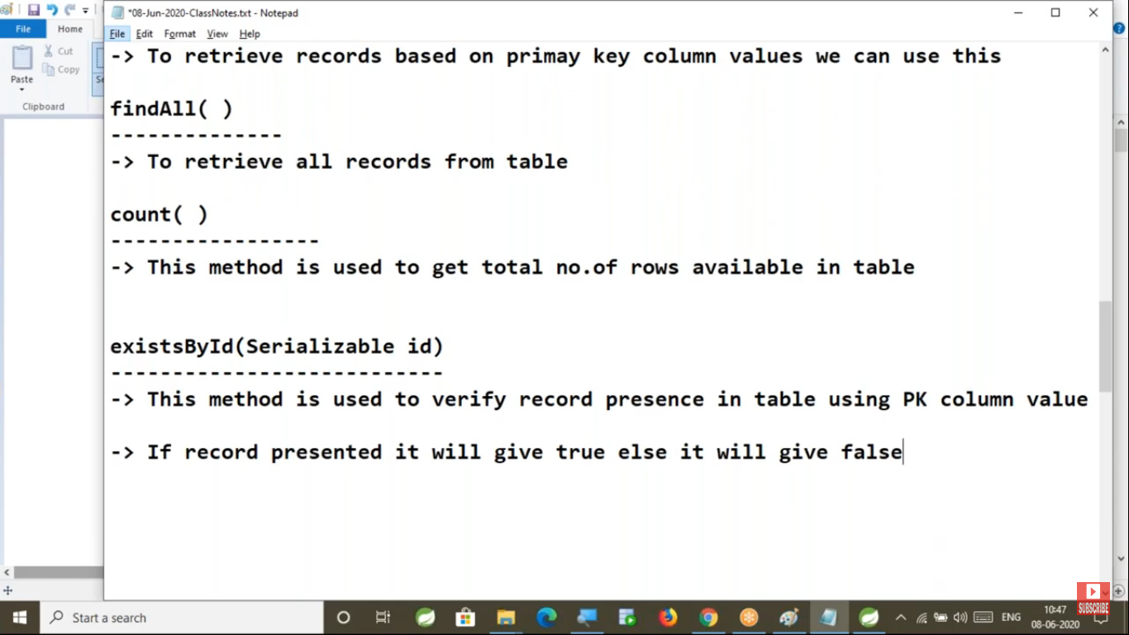

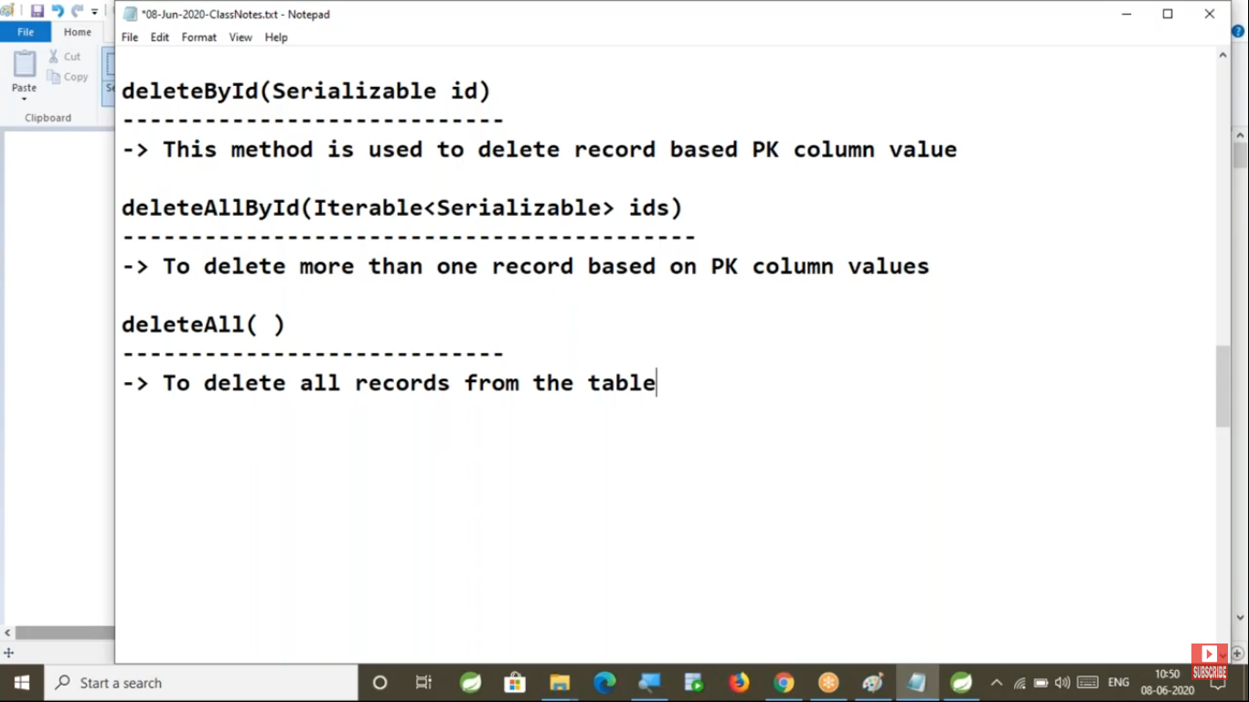

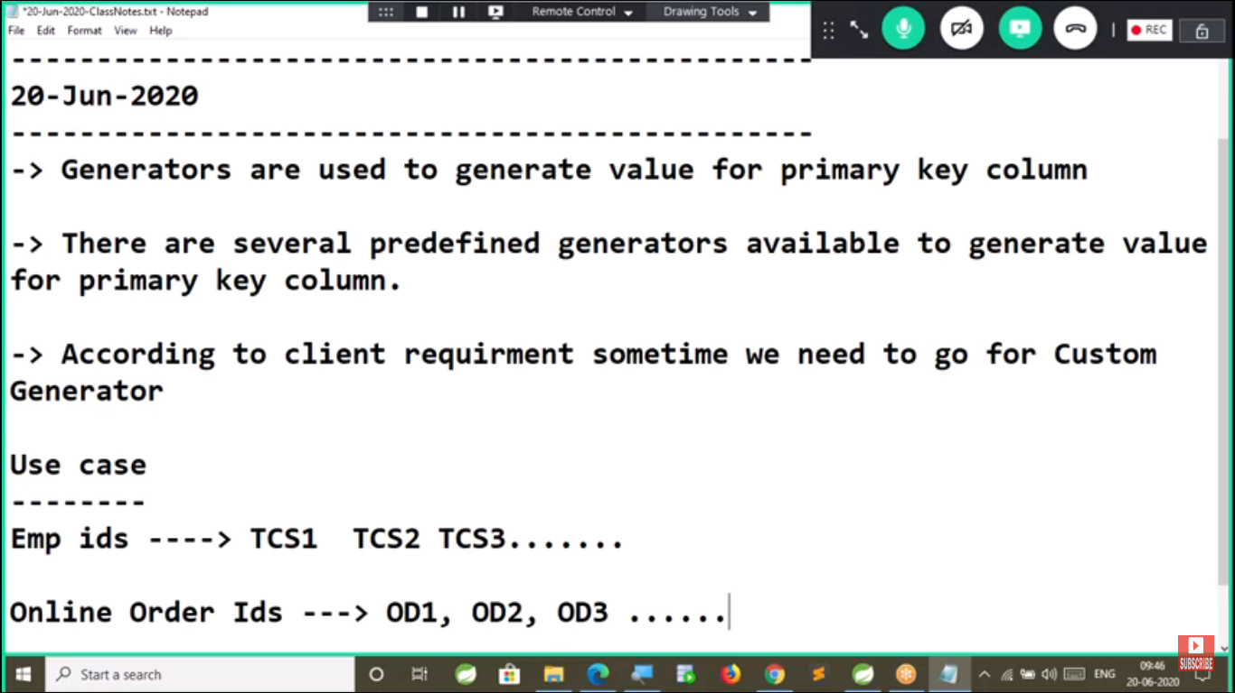

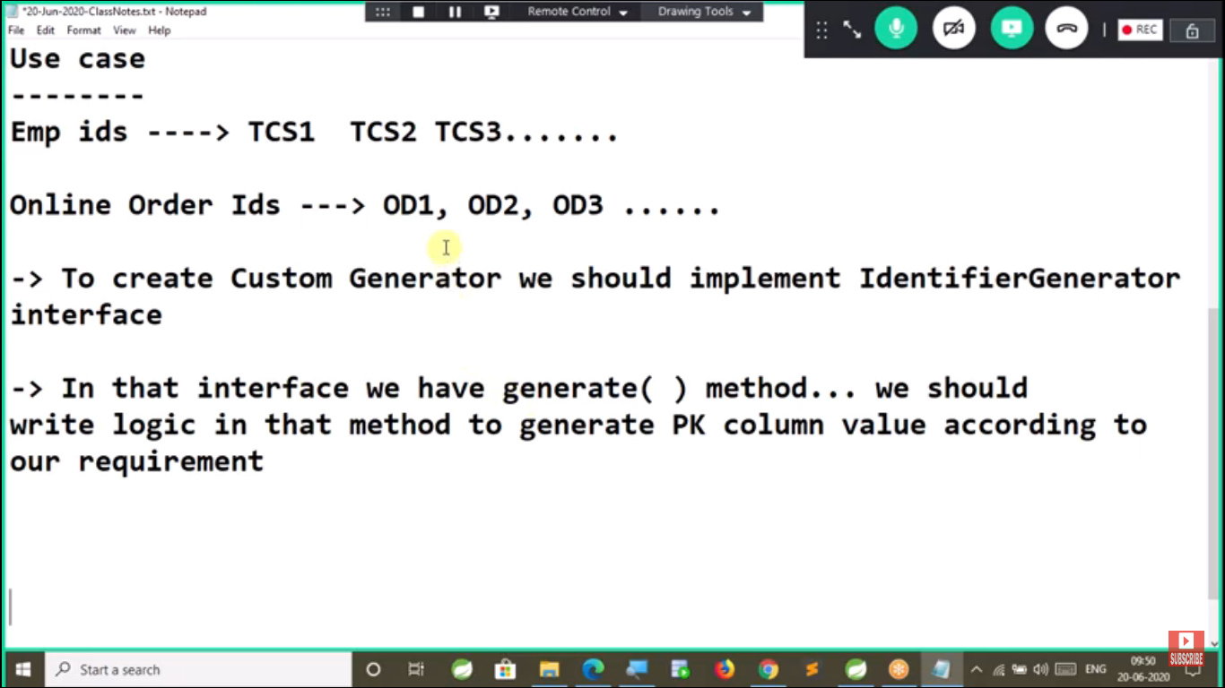

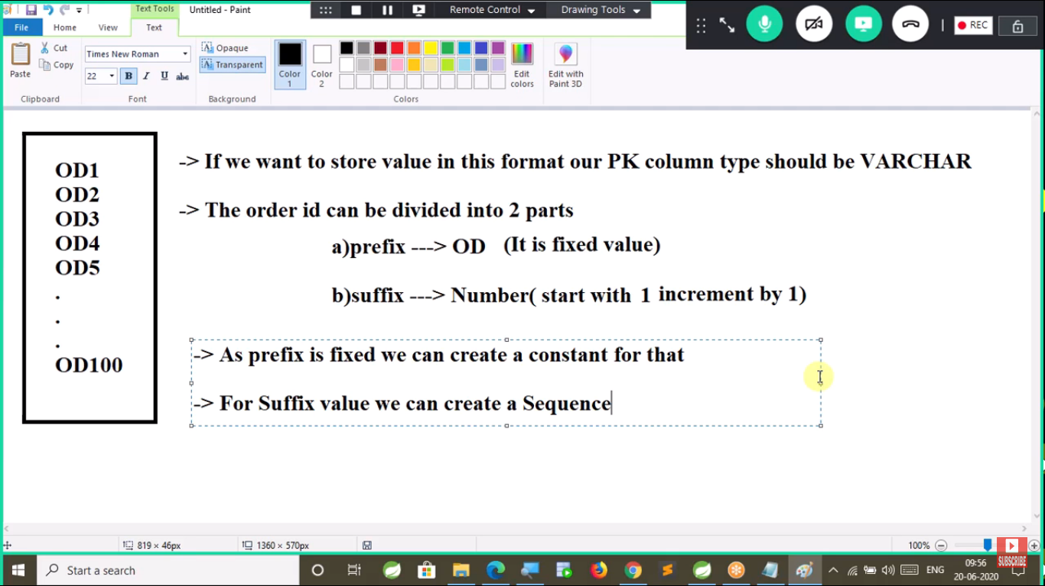

**Steps to develop Data JPA application with custom Generator**

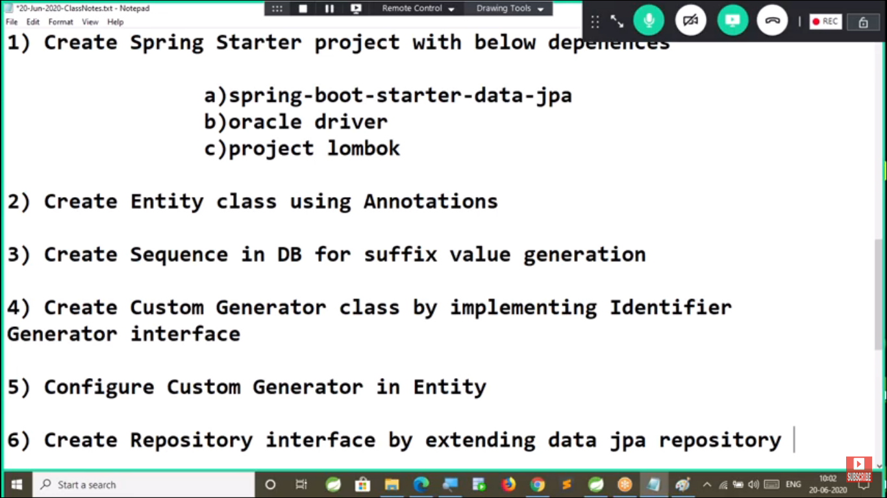

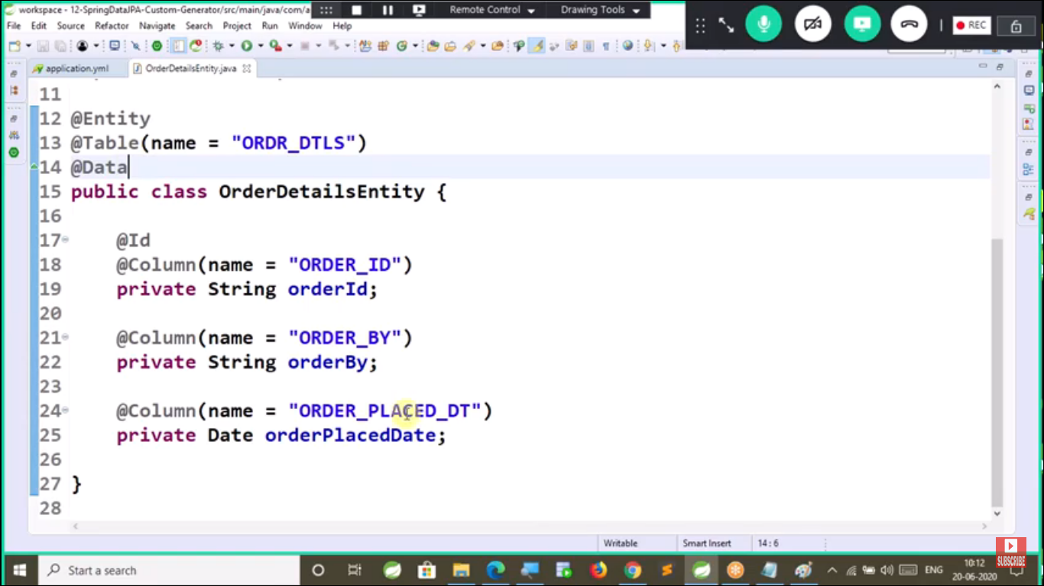

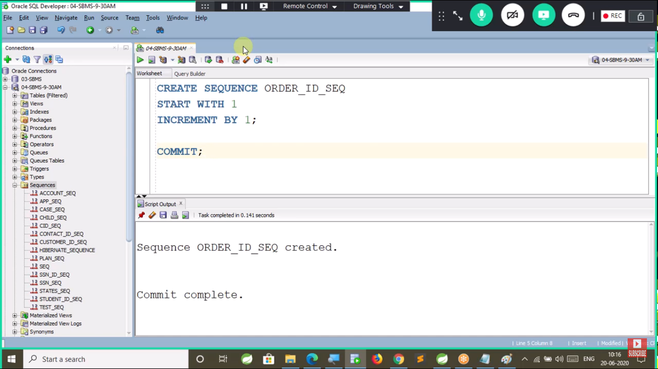

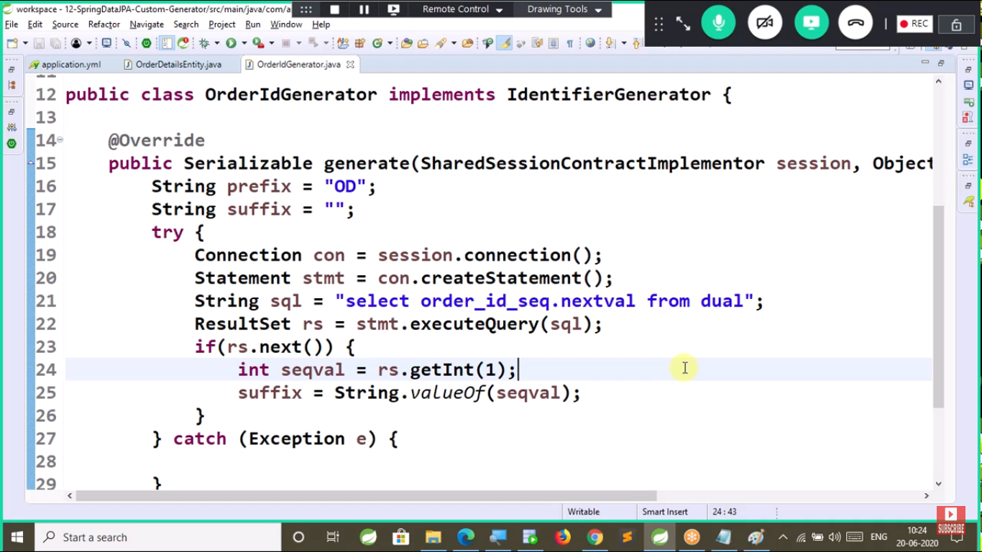

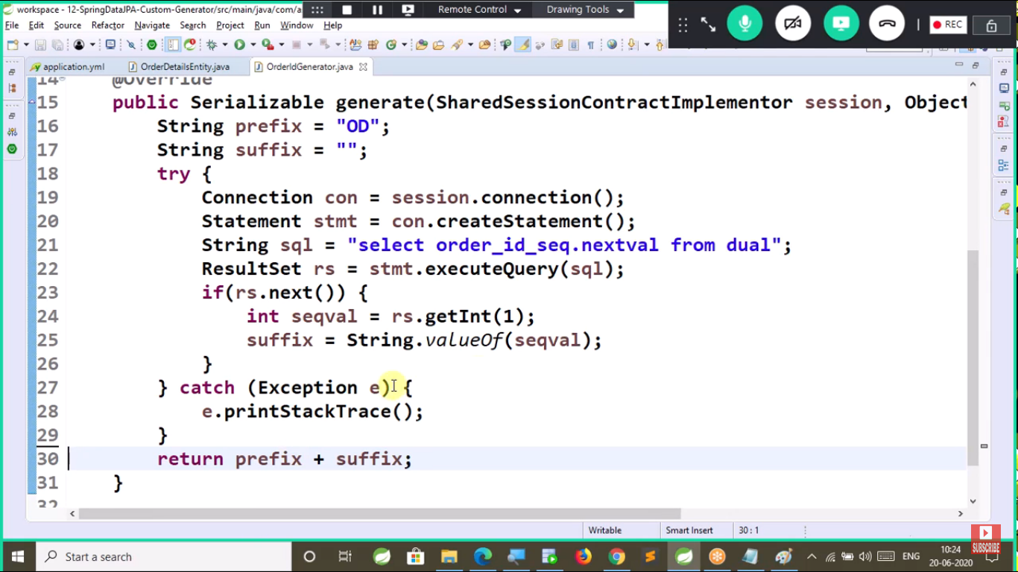

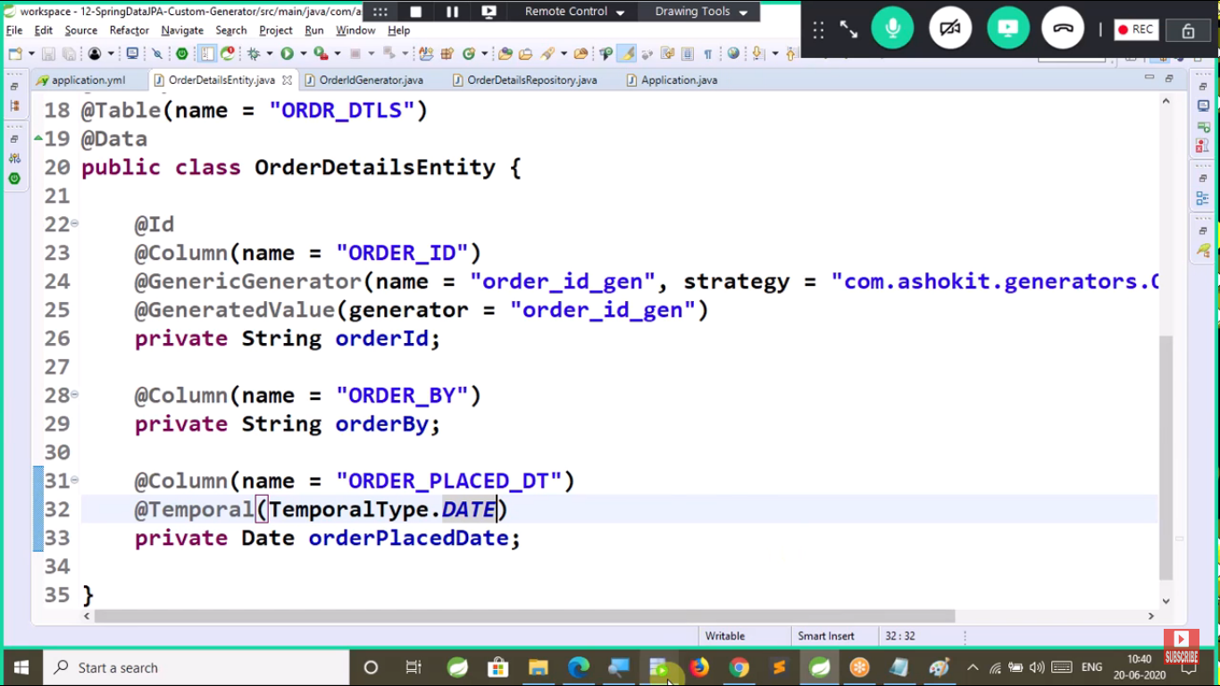

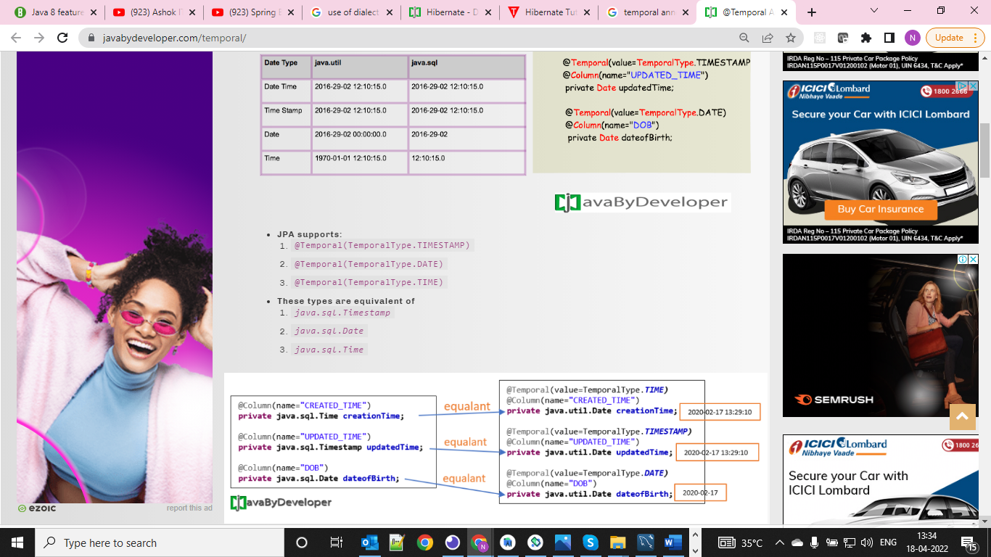

**Note: For ref** [**https://javabydeveloper.com/temporal/**](https://javabydeveloper.com/temporal/)

[**https://javabeat.net/jpa-annotations-generatedvalue-sequencegenerator-tablegenerator/**](https://javabeat.net/jpa-annotations-generatedvalue-sequencegenerator-tablegenerator/)

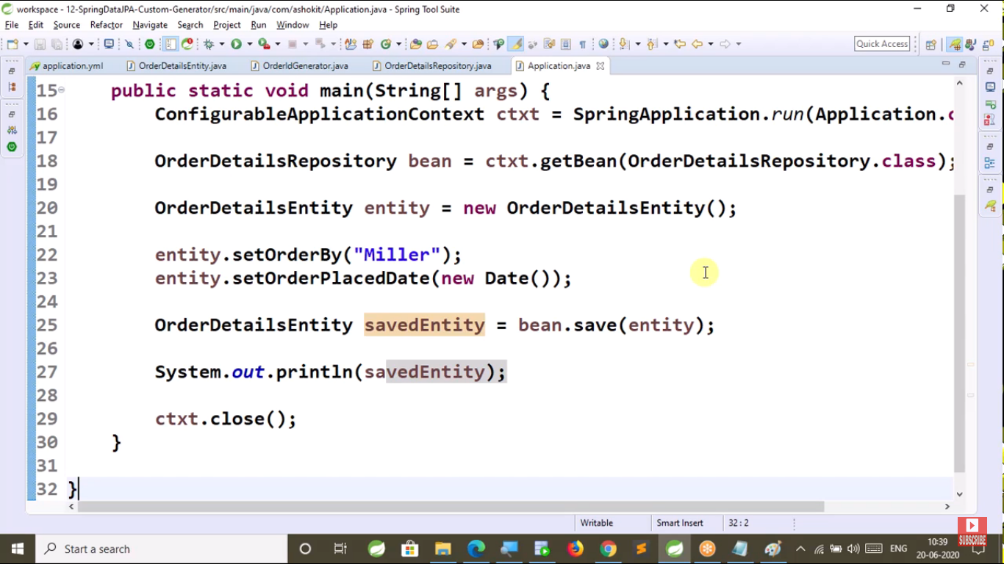

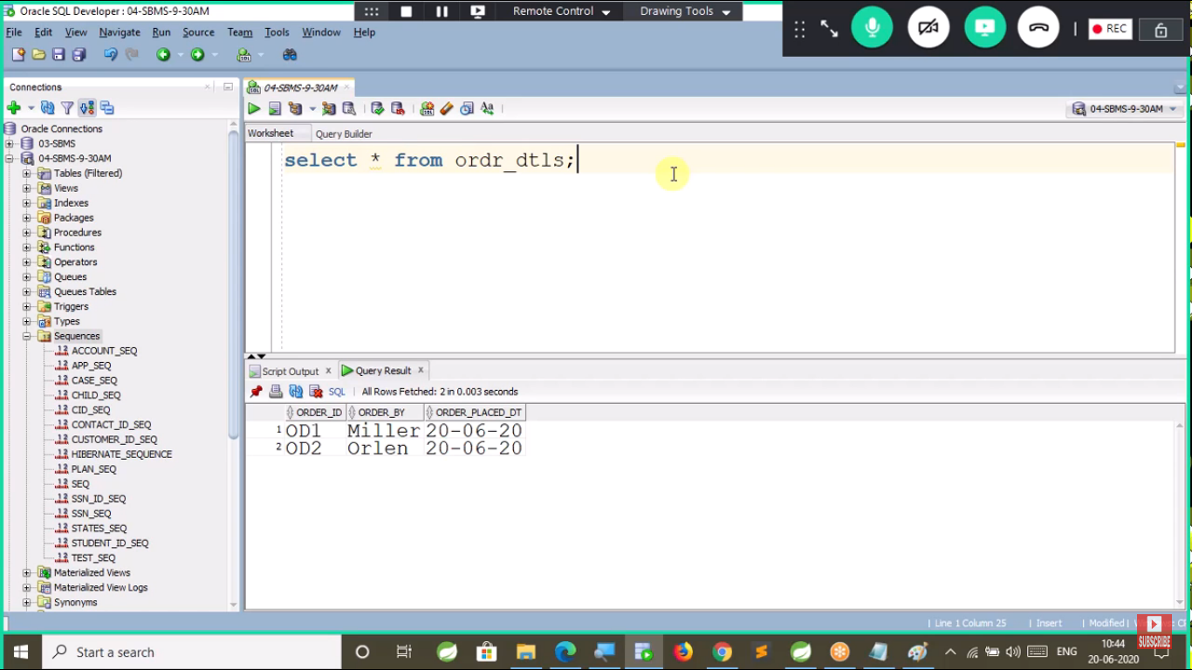

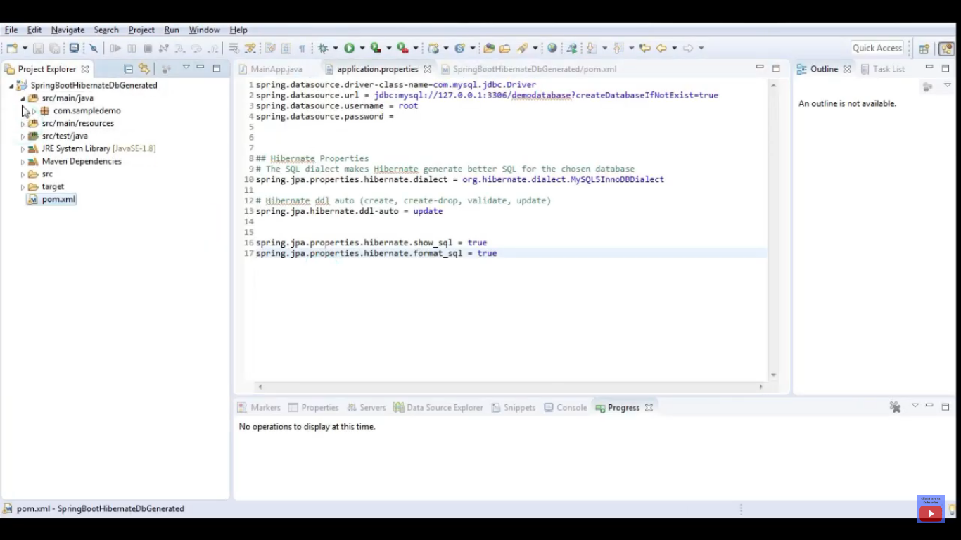

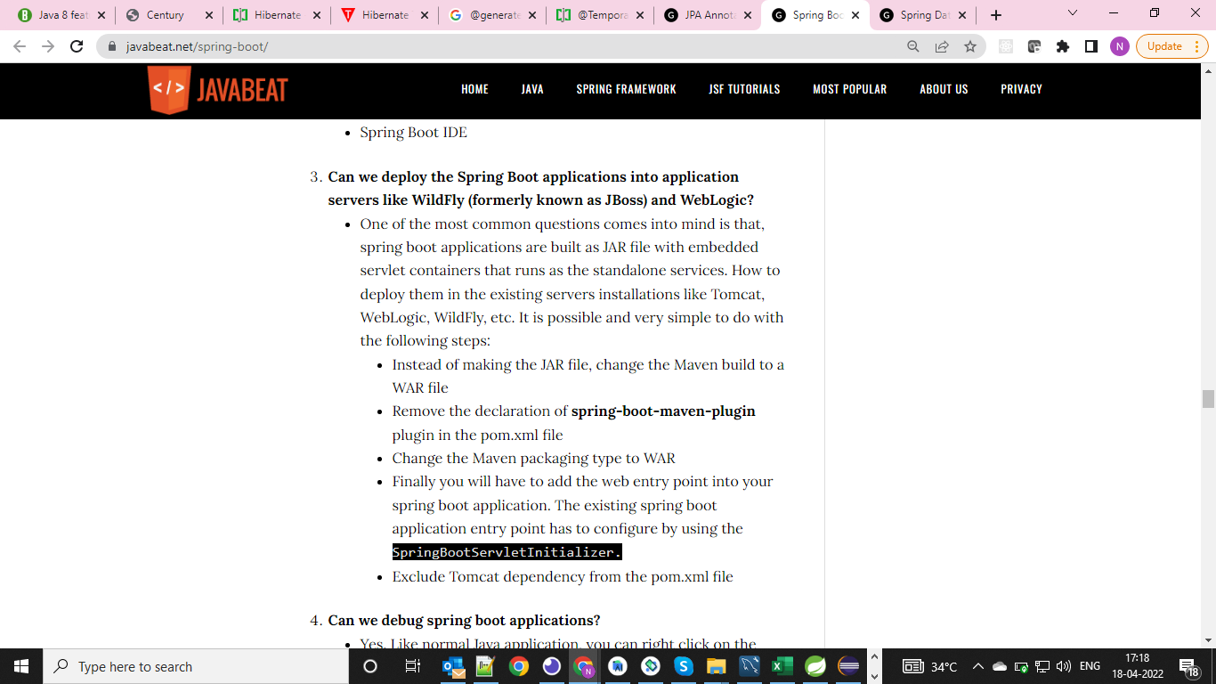

**Sample Application Using JPA**

**https://www.youtube.com/watch?v=XszpXoII9Sg&t=990s**

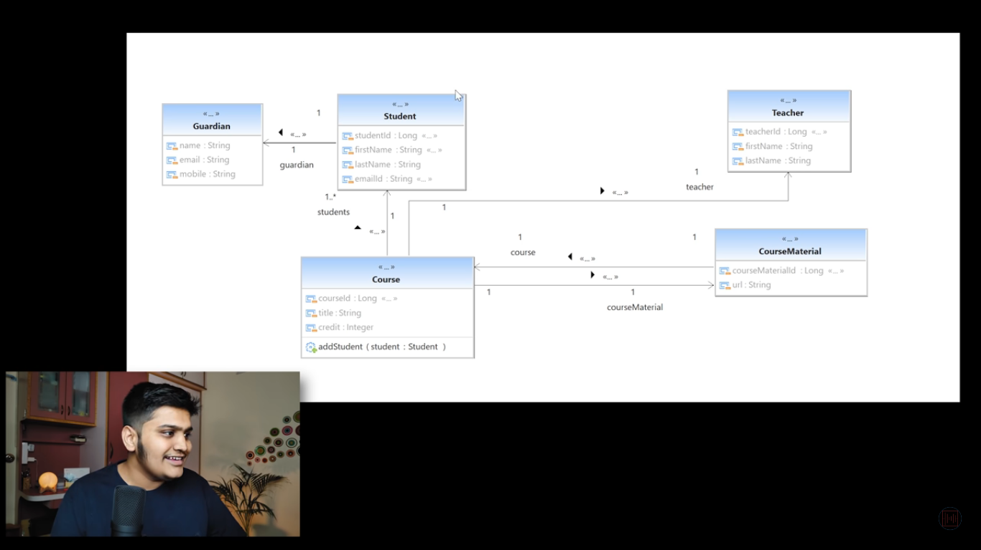

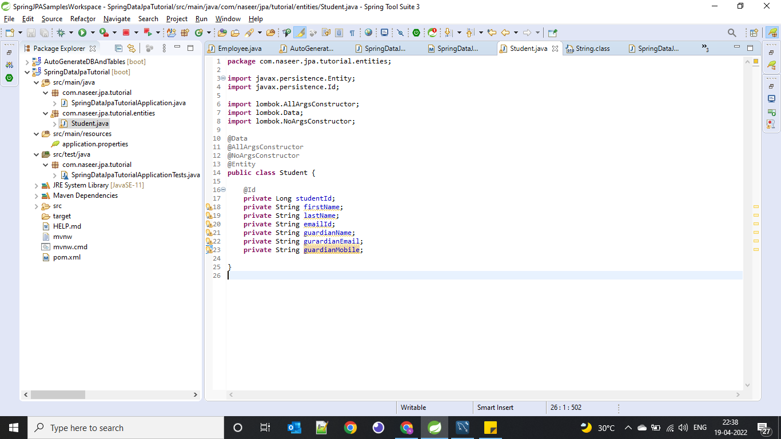

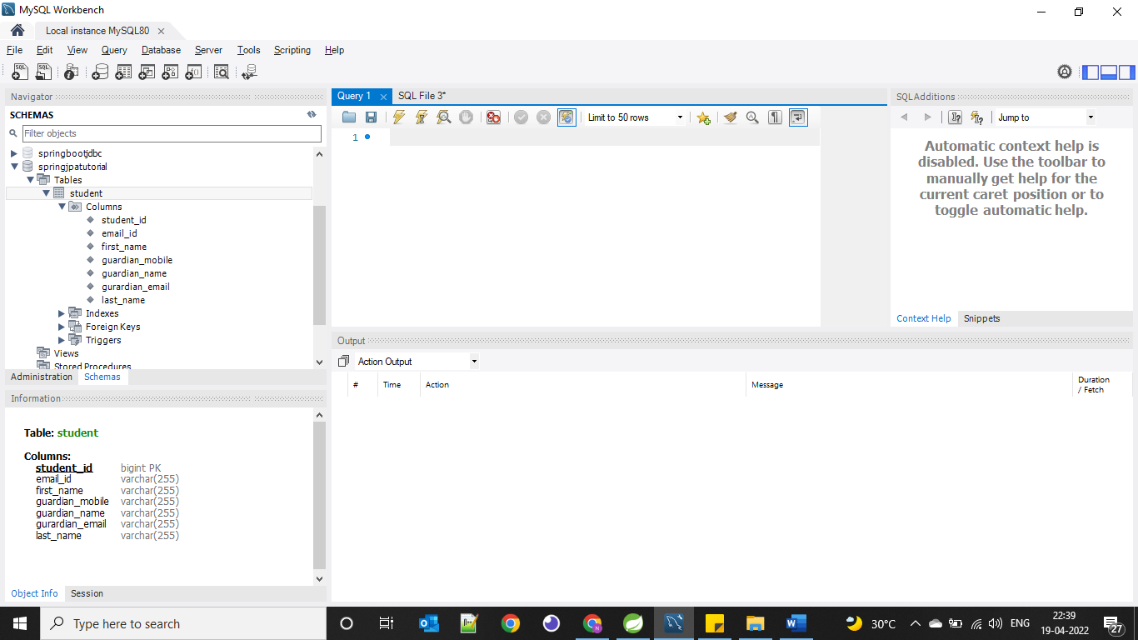

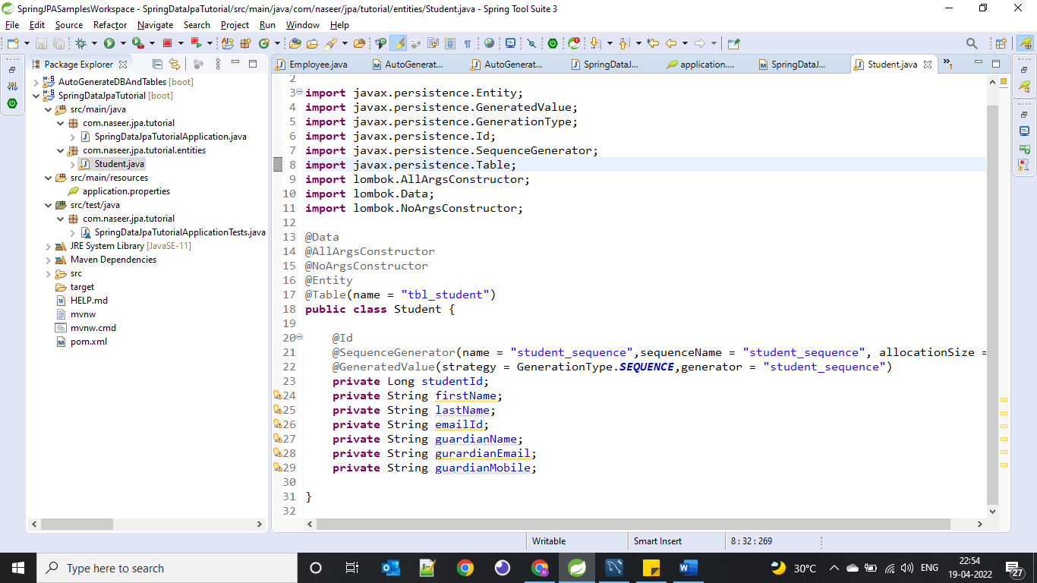

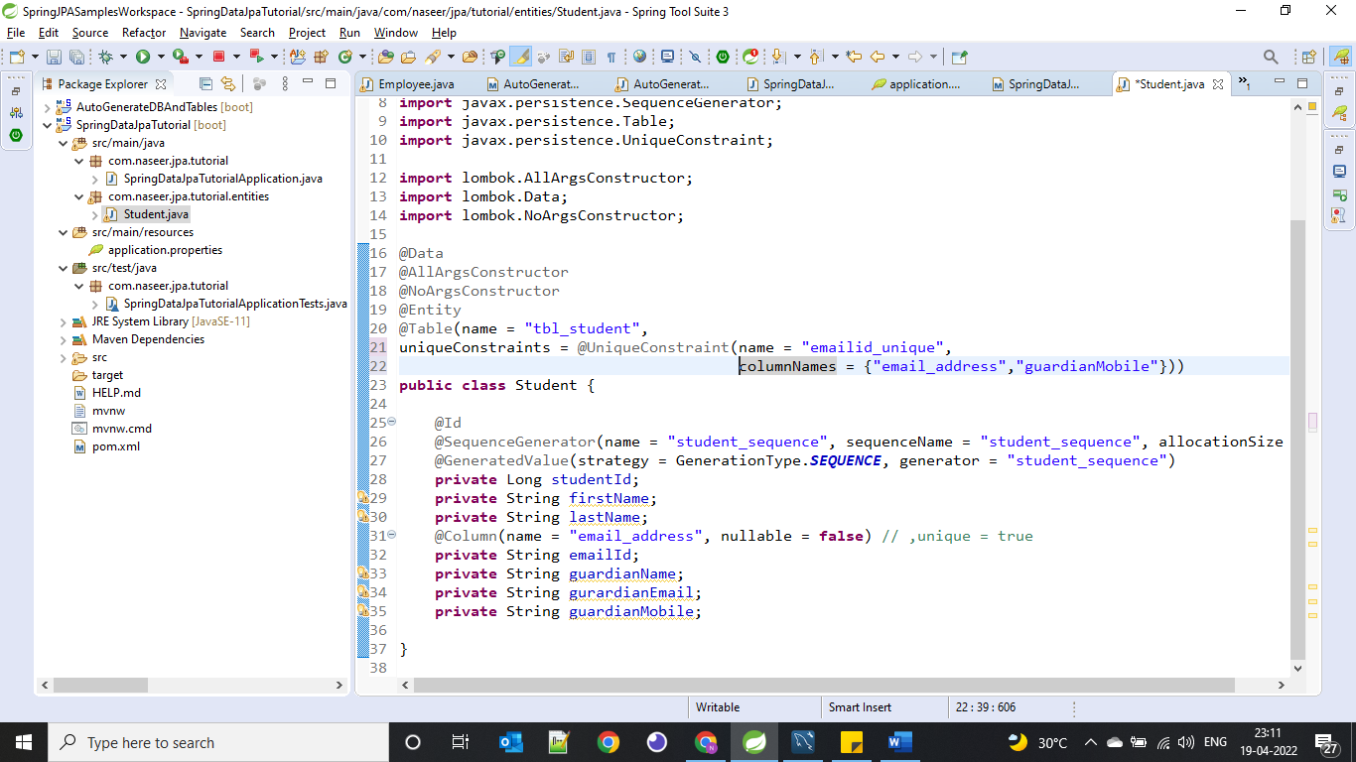

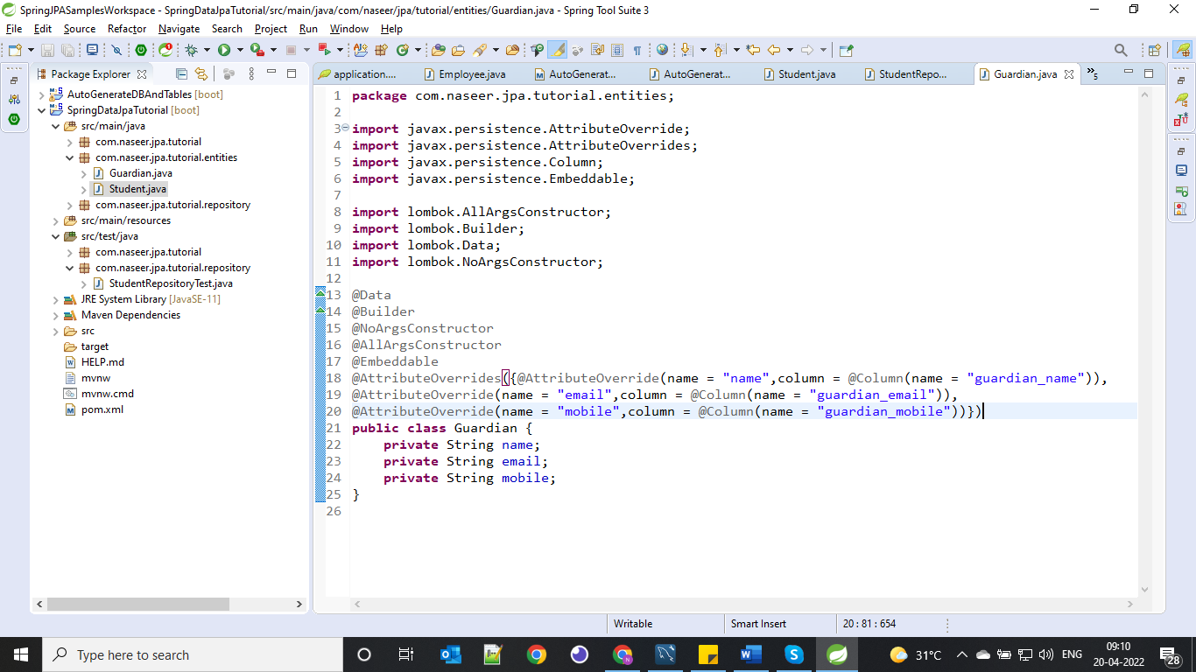

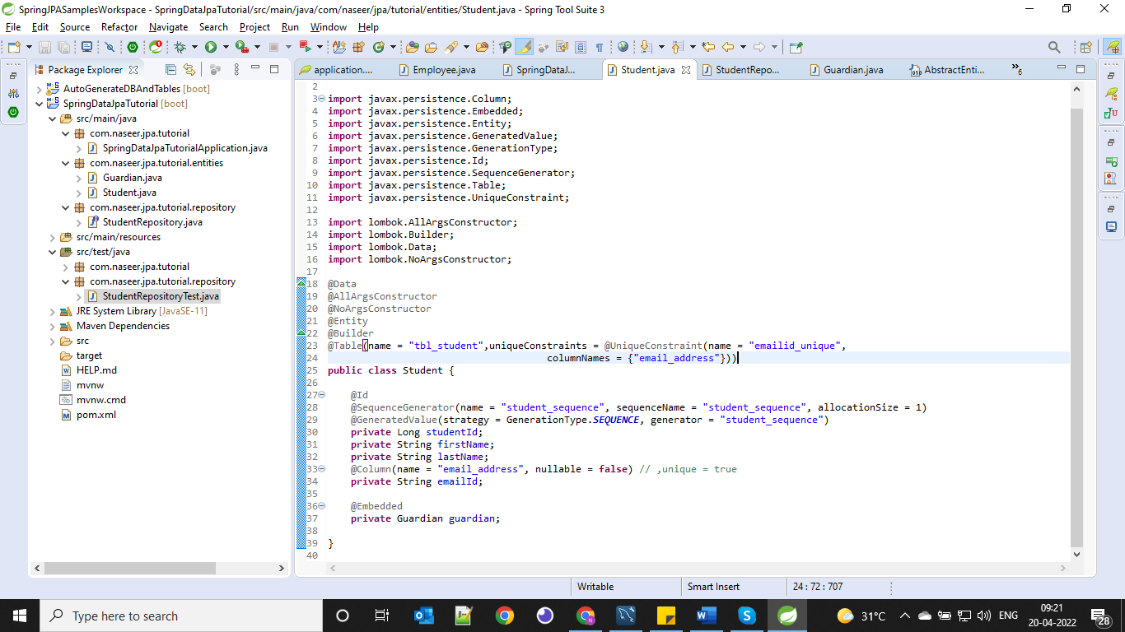

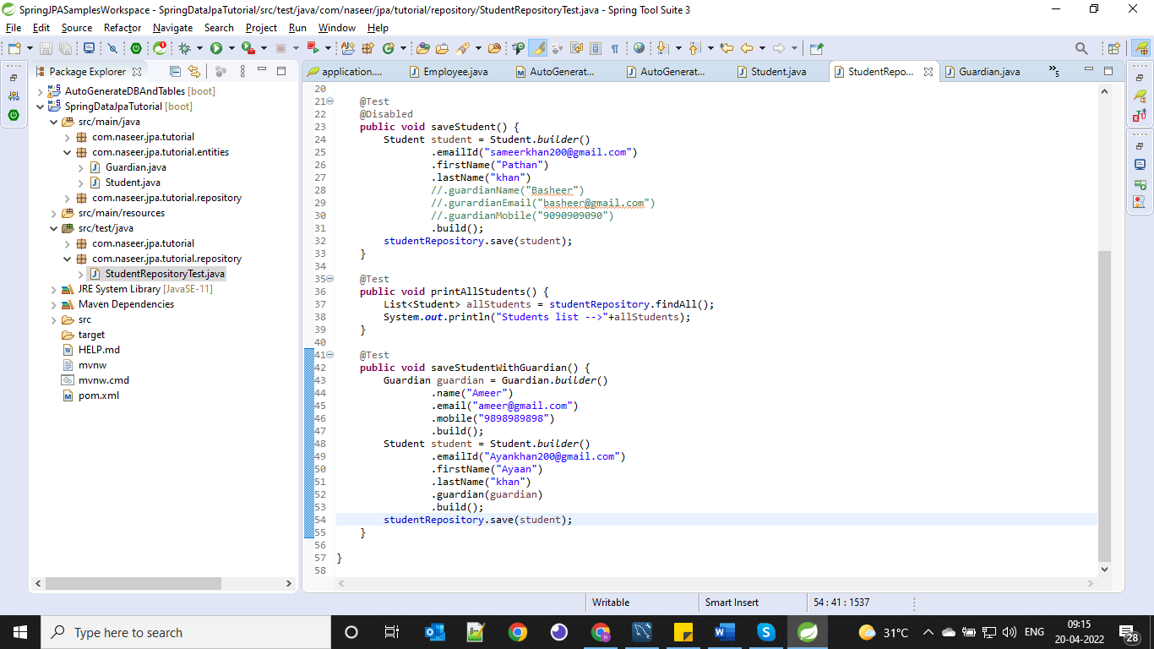

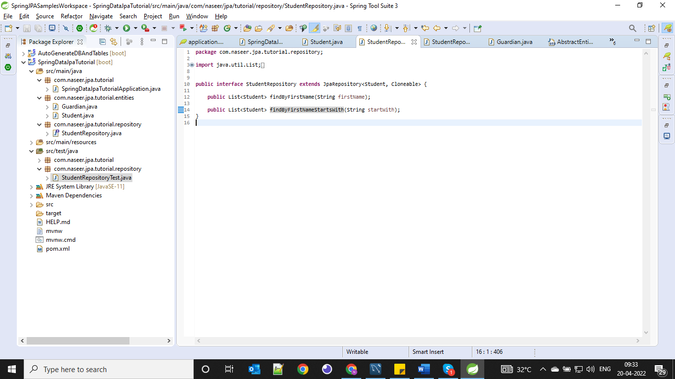

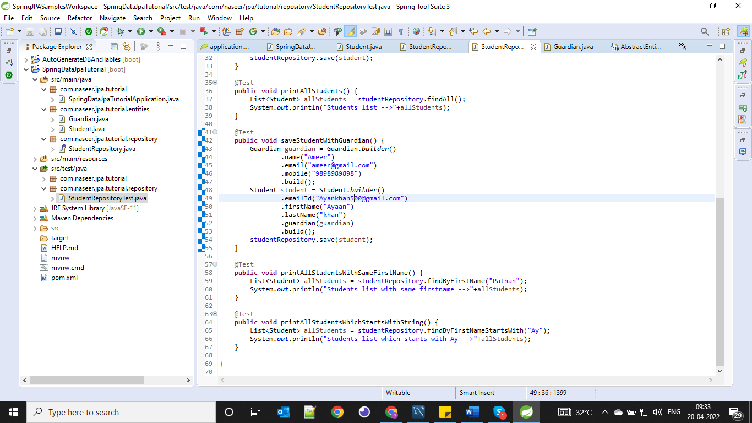

[**https://docs.spring.io/spring-data/jpa/docs/current/reference/html/#repositories.query-methods**](https://docs.spring.io/spring-data/jpa/docs/current/reference/html/#repositories.query-methods)

[**https://docs.spring.io/spring-data/jpa/docs/current/reference/html/#appendix.query.method.subject**](https://docs.spring.io/spring-data/jpa/docs/current/reference/html/#appendix.query.method.subject)

**@Modifying**

**@Transactional**

**These two annotations will use in service layer methods when we perform multiple update operations on multiple tables. Whenever all the transactions success then only those changes will commit in the database otherwise rollback all the operations.**

**Note: It is always better to go with Many to One relationship instead of one to Many relationship**

**GitHub Project Link :** [**https://github.com/shabbirdwd53/Spring-Data-JPA-Tutorial**](https://github.com/shabbirdwd53/Spring-Data-JPA-Tutorial)